**Aix Lab**

**A PROJECT REPORT**

**Submitted By**

**APOORVA SRIVASTAVA**

**University Roll No 1900290140008**

**Submitted in partial fulfillment of the**

**Requirements for the Degree of**

**MASTER OF COMPUTER APPLICATION**

**Under the Supervision of**

**Ms. NEELAM RAWAT**

### ASSOCIATE PROFESSOR



**Submitted to**

**Department Of Computer Applications**

**KIET Group of Institutions, Ghaziabad**

**Uttar Pradesh-201206**

**(June 2022)**

**DECLARATION**

I hereby declare that the work presented in this report entitled “AIX LAB", was carried out by me. I have not submitted the matter embodied in this report for the award of any other degree or diploma of any other University or Institute.

I have given due credit to the original authors/sources for all the words, ideas, diagrams, graphics, computer programs, experiments, results, that are not my original contribution. I have used quotation marks to identify verbatim sentences and given credit to the original authors/sources.

I affirm that no portion of my work is plagiarized, and the experiments and results reported in the report are not manipulated. In the event of a complaint of plagiarism and the manipulation of the experiments and results, I shall be fully responsible and answerable.

Name : Apoorva Srivastava

Roll. No. : 1900290140008

Branch : Master of Computer Application

**COMPANY CERTIFICATE**



**CERTIFICATE**

Certified that **Apoorva Srivastava (Roll No. 1900290140008)** have carried out the project work having “**Aix Lab**” for Master of Computer Applications from Dr. A.P.J. Abdul Kalam Technical University (AKTU**)** (formerly UPTU), Lucknow under my supervision. The project report embodies original work, and studies are carried out by the student himself/herself and the contents of the project report do not form the basis for the award of any other degree to the candidate or to anybody else from this or any other University/Institution.

**Date:**

**APOORVA SRIVASTVA**

**University Roll No 1900290140008**

This is to certify that the above statement made by the candidate is correct to the best of my knowledge.

Date:

**Ms. Neelam Rawat**

Associate Professor

Department of Computer Applications

KIET Group of Institutions, Ghaziabad

**Signature of Internal Examiner Signature of External Examiner**

**Dr. Ajay kr. Shrivastava**

**Professor & Head, Department of Computer Applications**

**KIET Group of Institutions, Ghaziabad**

**ABSTRACT**

AIx LAB is a Web application which is totally dedicated to Artificial Intelligence. In our web application there is a course based on Artificial Intelligence.

We have number of badges and every badges contain text information, videos and assessment regarding to the topics in AI, any user who want to know or grab complete knowledge about AI, he/she just need to create his/her own profile and get all the study material and tests. Along this if user have any query then there is an expert who can solve all the problem and give complete solution to users. The track of user progress will be managed, showing how much data he has completed and how much more he has to cover. There is a final examination conducted after which the user is provided by a certificate if he/she scores above the required percentage.

Our website is a learning platform which enables users to gain information regarding the topic Artificial Intelligence in a systematic format. Here we have Quality content, self-directed learning, reliable data and creative design which plays an important role in attracting user attention and helps them achieve Quality Education. User can gain knowledge from any corner of the world, all he needs is proper Internet connection and he can Sign Up to our website .Our website is easy to use, secure and the contents are divided according to the topics which is easily accessible.

**ACKNOWLEDGEMENT**

Success in life is never attained single handedly. My deepest gratitude goes to my thesis supervisor, **Ms. Neelam Rawat**  for his guidance, help and encouragement throughout my research work .Their enlightening, ideas, comments, and suggestions.

Words are not enough to express my gratitude to **Dr. Ajay Kumar Shrivastava, Professor and Head, Department of Computer Applications**, for his insightful comments and administrative help at various occasions.

Fortunately, I have many understanding friends, who have helped me a lot on many critical conditions.

Finally, my sincere thanks go to my family members and all those who have directly and indirectly provided me moral support and other kind of help. Without their support, completion of this work would not have been possible in time. They keep my life filled with enjoyment and happiness.

**Apoorva Srivastava**

**TABLE OF CONTENTS**

Page no.

Declaration ii

Company Certificate iii

Certificate iv

Abstract v

Acknowledgement vi

**CHAPTER 1: INTRODUCTION 1-5**

* 1. Project Description 1
  2. Project Purpose 3
  3. Project Schedule 4
  4. Hardware / Software used in Project 5

**CHAPTER 2: LITERATURE REVIEW 6-9**

**CHAPTER 3: TECHNICAL FEASIBILITY 10-12**

3.1 Technical Feasibility 10

3.2 Technology Description 11

**CHAPTER 4: REQUIREMENT ANALYSIS 13-16**

4.1 Software Requirement Analysis 13

4.2 User Interface Requirements 14

4.3 System Requirements 14

4.4 Functional Requirements 15

4.5 Non-Functional Requirements 16

**CHAPTER 5: FEASIBILITY STUDY 17-19**

5.1 Introduction 17

5.2 Technical Feasibility 17

5.3 Economical Feasibility 18

5.4 Operational Feasibility 19

5.5 Social and Behavioral Feasibility 19

5.6 Legal Feasibility 19

**CHAPTER 6: SYSTEM DESIGN 20-32**

6.1 Class Diagram 20

6.2 Use Case Diagram 21

6.3 Data Flow Diagram 22

6.4 Database Tables 28

**CHAPTER 7: SNAPSHOTS 33-44**

**CHAPTER 8: CODING 45-69**

**CHAPTER 9: TESTING 70-75**

9.1 Introduction 70

9.2 Unit Testing 71

9.3 Validation Testing 72

9.4 Output Testing 72

9.5 Integration Testing 73

9.6 User Acceptance Testing 74 9.7 Black Box Testing 74

9.8 White Box Testing 75

**CHAPTER 10:CONCLUSION AND FUTURE SCOPRE 76**

**CHAPTER 11:REFERENCES 77-78**

**LIST OF FIGURES**

1.1 PROJECT SCHEDULE 4

6.1 CLASS DIAGRAM 20

6.3 0 LEVEL DFD 24

6.4 1 LEVEL DFD 25

6.5 ER DIAGRAM 28

7.1 HOME PAGE 33

7.2 ABOUT US 35

7.3 CONTACT US 36

7.4 USER SIGN UP 36

7.5 USER SIGN IN 37

7.6 USER HOME PAGE 37

7.7 VIEW BADGES 38

7.8 STUDY MODULES 38

7.9 MODULE TEST 40

7.10 GIVE REVIEWS 41

7.11 MY PROFILE 41

7.12 EDIT PROFILE 42

7.13 CHANGE PASSWORD 42

7.14 FINAL EXAMINATION 43

7.15 RESULT 44

**Chapter – 1**

**INTRODUCTION**

**1.1 PROJECT DESCRIPTION**

Our website is a learning platform which enables users to gain information regarding the topic Artificial Intelligence in a systematic format. Here we have Quality content, self-directed learning, reliable data and creative design which plays an important role in attracting user attention and helps them achieve Quality Education. User can gain knowledge from any corner of the world, all he needs is proper Internet connection and he can Sign Up to our website .Our website is easy to use, secure and the contents are divided according to the topics which is easily accessible.

We have numbers of badges and every badges contain text information, videos and assessment regarding to the topics in AI, any user who want to know or grab complete knowledge about AI, he/she just need to create his/her own profile and get all the study material and tests. Along this if user have any query then there is an expert who can solve all the problem and give complete solution to users. The track of user progress will be managed,showing how much data he has completed and how much more he has to cover.Their is a final examination conducted after which the user is provided by a certificate if he/she scores above the required percentage.

**ADMIN PANEL:**

On the admin panel, the admin can login after which he or she is redirected to the dashboard of admin panel. The admin panel has links which includes:

* View the number of user
* View the number of expert
* Expert approval
* View the Examination Result
* Send Notifications
* View user reviews
* Provide certificate

**EXPERT PANEL:**

On the expert panel, the experts can login after which he or she is redirected to the dashboard of expert panel. The expert panel has links which includes:

* Addition of badges
* Addition of content
* Addition of questions related to content
* Addition of final examination questions
* Conduct final examination
* Send notifications
* View user reviews
* Online chat

**USER PANEL:**

On the user panel, the users can login after which he or she is redirected to the dashboard of user panel. The user panel has links which includes:

* View of User home
* View badges
* Give reviews
* Take final examination
* Get certificate

The main focus of our website is on user convenience. You won’t be forced to interrupt your job or college life to attend some class to gain knowledge and some certificate, So you can gain credentials that will make you more valuable at your work or at a future job, without impacting your current situation.

# Problem with Existing System:

The main problem with students while searching for content is that whenever any user wants to search about Artificial Intelligence then they get the information in scattered way for example to search a text regarding a topic of Artificial Intelligence they go to Wikipedia, for video content of the same topic they go to YouTube or for any other info they might be go to other platform.

If any user has any query regrading topics of Artificial Intelligence then there is no one who could solve those.

User might not be satisfied with the information and cannot get full knowledge about Artificial intelligence. This is one of the major problems in student’s and professor’s lives.

**1.2 PROJECT PURPOSE**

* The aim of AIx LAB is to provide users complete knowledge of Artificial Intelligence on a single platform in the form of videos, images and text data.
* User can directly communicate to the expert if he has any queries regarding the topic.
* AIx LAB provides number of badges in a systematic format from a Beginner to Higher level.
* AIx LAB provides a certificate after the completion of all modules by conducting a Final Examination.
* The user can access this website anytime and from anywhere according to their convenience.
* This website is helpful for professionals /students and to anyone who is willing to learn regarding this particular topic.

**1.3 PROJECT SCHEDULE**

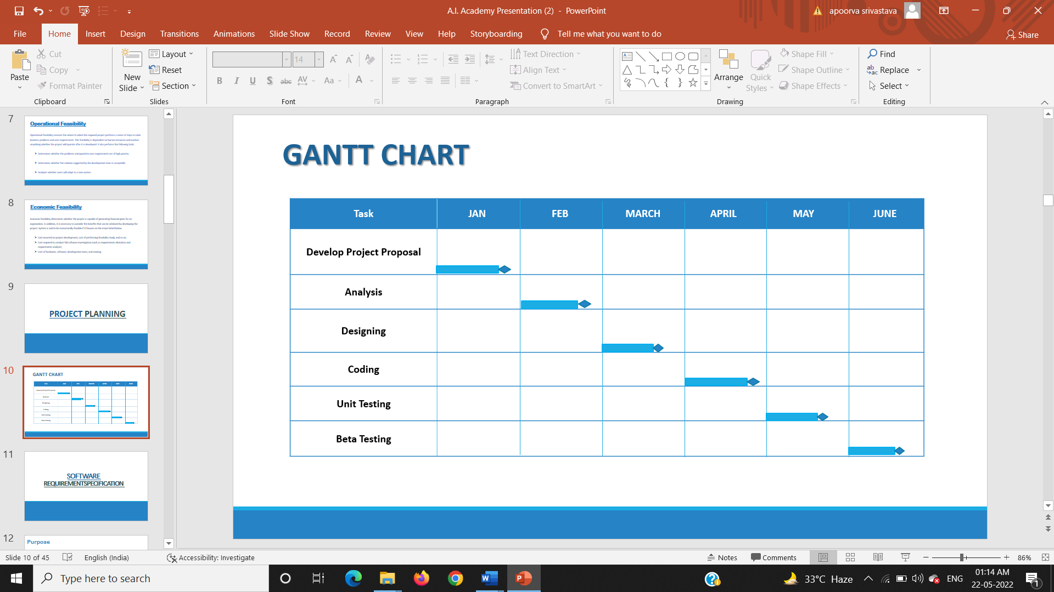

**Fig 1.1 GANTT CHART**

**1.4 HARDWARE /SOFTWARE USED IN PROJECT**

**Hardware Requirements:-**

**Client Side**

* + Processor : Dual Core or Above
  + RAM : 1 GB

**Server Side**

* Processor : Dual Core or Above
* RAM : 1 GB

**Software Requirements:-**

**Client side**

* + Operating System: Windows 10 or Above,
  + Browser: Any browser

**Server side**

* Operating System: Windows 10 or Above
* Browser: Any browser
* Front-end: MS Visual Studio 2017
* Server: IIS
* Back-end: MS SQL Server 2017

**Chapter – 2**

**LITERATURE REVIEW**

Teaching and learning processes have not experienced major changes during the last centuries. However, eLearning platforms may transform these processes, turning the classroom from a teacher-centered and standardized space into a student-centered, customizable and highly scalable environment. These changes impact many different stakeholders such as parents, teachers, universities, software developers and textbook publishers. Therefore, to fully understand the adoption process of an innovation such as eLearning, using traditional technology adoption models that center on a single stakeholder (the end-user) may not be enough. Perspectives from multiple stakeholders must be considered. These stakeholders may come from different industries that make up an ecosystem. Hence, this study aims to explore eLearning adoption through an ecosystem perspective. [1]

This paper introduces an interactive e-learning system that provides an integrated environment for web programming. The proposed system is web-based. It provides an online editor for writing, editing, updating, and executing programming code, so the learners can execute examples and practical exercises online. In addition, it provides auto complete and syntax highlighting in editing code, which could help learners to remember the syntax more easily. The proposed system provides communication and interactive tools including Chat-Room, E-Mail, and Discussion Board (Forum) among learners and instructors. Moreover, it provides the instructors with an online exam system. It monitors, collects and keeps information about learners’ performance and activities.[2]

A comparison was made on perceptions on 26 factors relating to motivation, satisfaction, and goal setting/feedback for programmer/analysts and programmers in the U.S. Israel, and Singapore. Surveys of over 550 Israelis and 1100 Singaporeans were compared to a US database on more than 8000 computer personnel. The Job Diagnostic Survey for Data processing (JDS/DP) instrument was used to collect all data. The survey results indicated a mismatch in individual growth need and the job's motivating potential for programmers in Israel and Singapore. A mismatch also exists for Singaporean programmer/analysts. A procedure for improvement is discussed.[3]

Learning by Imitation (LBI) is the most natural way of learning natural languages. The designers of online courses focus on approaches like learning by doing, adaptive learning, and so on for designing online education systems like Massive Open Online Courses (MOOC) and Intelligent Tutoring System (ITS). They don't consider LBI as an essential parameter while designing courses and MOOC/ITS for naive programmers. The purpose of this research is to arrive at a framework that helps in designing pedagogically effective MOOC/ITS for naive programmers which reflects LBI approach.[4]

Within computer science education, we have spent considerable effort on the introduction to the discipline (particularly to programming) and the teaching of novice programmers. However, we do not often think about the teaching and learning for the intermediate students. Having data about student's perceptions coming into a second year data structures course, it became of interest to systematically analyze the data to see what if any interesting patterns or results we could see in this information. Using the data from a first day of class general survey, we were able to gather information about student's perceived level of difficulty with some of the major topics that they have studied up until this point in the curriculum. [5]

With the increasing popularity of the web, some new web technologies emerged and introduced dynamics to web applications, in comparison to HTML, as a static programming language. JavaScript is the language that provided a dynamic web site which actively communicates with users. JavaScript is used in today's web applications as a client script language and on the server side. The JavaScript language supports the Model View Controller (MVC) architecture that maintains a readable code and clearly separates parts of the program code. The topic of this research is to compare the popular JavaScript frameworks: AngularJS, Ember, Knockout, Backbone. All four frameworks are based on MVC or similar architecture. In this paper, the advantages and disadvantages of each framework, the impact on application speed, the ways of testing such JS applications and ways to improve code security are presented.[6]

The object-oriented paradigm is becoming increasingly popular as a result of expert opinion and anecdotal evidence and not on the basis of sound empirical data. The questionnaire survey was undertaken as part of a programme of research to validate unsupported claims about the paradigm. The questionnaire follows structured interviews of experienced object-oriented developers with the intention of confirming the findings on a wider practitioner group. It was posted to relevant electronic newsgroups and to members of an object-oriented (postal) mailing list. The survey received 167 responses to the electronic questionnaire and 119 responses (30% response rate) to the postal version.[7]

Web applications (apps) programmed using HTML, CSS, and JavaScript have advantages in portability and productivity, compared to Android or IOS apps. However, web apps are involved with some performance issue, due to JavaScript with its dynamic typing and prototypes which are difficult to execute efficiently. One popular way of accelerating JavaScript is using the just-in-time compilation (JITC), which translates the JavaScript source code to the machine code at runtime.[8]

JavaScript has become a popular programming language. It is widely used in both client-side and server-side programming in web applications. The robustness and performance of JavaScript programs become vital. Unfortunately, real-world JavaScript programs often suffer from various issues. In this work, we present nine issue patterns derived from open-source projects and propose a general static analysis framework, JSOptimizer, to help detect such patterns of issues and optimize the code accordingly. Comparing to existing work, JSOptimizer is not only highly extensible but also performs code optimizations automatically. We applied JS Optimizer to seven real open-source JavaScript projects and five bugs detected by it have been confirmed by developers. [9]

Recruiting professional programmers in sufficient numbers for research studies can be challenging because they often cannot spare the time, or due to their geographical distribution and potentially the cost involved. Online platforms such as Clickworker or Qualtrics do provide options to recruit participants with programming skill; however, misunderstandings and fraud can be an issue. This can result in participants without programming skill taking part in studies and surveys. If these participants are not detected, they can cause detrimental noise in the survey data. We also evaluated the questions in an adversarial setting. We conclude with a set of recommended questions which researchers can use to recruit participants with programming skill from online platforms.[10]

There are few resources geared to technical writers working on documentation for software developers. This paper presents the results of online surveys and telephone interviews that cover the experience, technical knowledge, and practices of technical writers in this area, with a large percentage of respondents who are Microsoft employees. Respondents value strong writing skills and the ability to learn quickly and continuously, with the amount and type of knowledge needed being specific to the subject area and audience for their work.[11]

Computing historians might someday refer to 2005 as the year of XML. Many have anticipated the promise of XML for almost a decade, but major industry players finally accepted in 2005 that the nuts and bolts of XML processing in the heart of their networks will demand new ways of thinking. This analysis specializes in Web services and service-oriented architecture (SOA) issues.[12]

E-Learning is the use of telecommunication technology to deliver information for education and training and it is emerging as the new paradigm of modern education. Because of the increasing amount of technology integration in the learning environment, more and more studies focus on examining “how people learn with technology” This study was conducted to find out how computer assisted language learning contributes to learners’ ability to develop listening comprehension. The results revealed that learner computer anxiety, instructor attitude toward e-Learning, e-Learning course flexibility, e-Learning course quality, perceived usefulness, perceived ease of use, and diversity in assessments are the critical factors affecting learners’ perceived satisfaction.[13]

Information on the Web, which are conglomeration of heterogeneous data, such as texts, images and audio clips, are often accessed through documents written according to the HTML specification. According to the HTML specification, HTML documents are semistructured in nature. We propose a high-level stack machine (HSM) which accesses an HTML document through its URL and constructs a semistructured data graph (SDG) of the document. The SDG of an HTML document H precisely captures the structure of the semistructured data embedded in H based on the dependency relationship among the data objects in H. HSM is configurable to accommodate a user's interest with respect to the HTML elements in H to be considered during the construction process of the SDG of H.[14]

Computer networks connection becomes the most important way for people to contact each other, share information, and transmit privacy data. Because the Internet is not secure enough, data hiding techniques provide a good manner to deliver secret data with security. HTML webpage not only can be used to advertise a company's product but also used to share someone experience or knowledge. The HTML file is different from a digital image because it is composed of tags but pixels. CSS provides more options and assistance to help HTML file coding to create colorful web pages. The proposed method utilizes both HTML and CSS's properties to achieve the goal of secret data delivery. The experimental results indicate that the proposed method has a larger embedding capacity than others.[15]

**Chapter – 3**

**TECHNICAL FEASIBILITY**

**3.1 TECHNICAL FEASIBILITY**

This is concerned with specifying equipment and software that will successfully satisfy the user requirement. There are number of technical issues which are generally raised during the feasibility stage of the investigation.

•The proposed project category is Relational Database Management System. I have used

SQL Server as back end and C# .NET as a front end.

•This project is an online web based application.

•Using the internet anybody in the world can access this application across the world.

•Web based application are easily managed and updated intently.

**3.2 TECHNOLOGY DESCRIPTION**

1. **.Net Framework 4.5**

The .NET Framework 4.5 is a highly compatible, in-place update to the .NET Framework 4. By using the .NET Framework 4.5 together with the C#, Visual Basic, or F# programming language, you can write Windows apps. The .NET Framework 4.5 includes significant language and framework enhancements for C#, Visual Basic, and F# (so that you can more easily write asynchronous code), the blending of control flow in synchronous code, a responsive UI, and web app scalability . The .NET Framework 4.5 adds substantial improvements to other functional areas such as ASP.NET, Managed Extensibility Framework, Windows Communication Foundation, Windows Workflow Foundation, and Windows Identity Foundation. The .NET Framework 4.5 delivers better performance, reliability, and security.



**Fig 3.1** **.Net Framework 4.5 Logo**

##### **C#**

C# (pronounced C-Sharp) is a new programming language introduced with the Microsoft .NET framework and is no doubt the language of choice in .NET environment. It was first created in the late 1990's as part of Microsoft’s whole .NET strategy. It is a whole new language free of backward compatibility curse and a whole bunch of new, exciting and promising features. It is an Object Oriented Programming language, which at its core, has similarities with Java, C++ and VB.

In fact, C# combines the power & efficiency of C++, simple & clean OO design of Java, and code simplification of Visual Basic. Like Java, C# also does not allow multiple inheritance and use of pointers (in safe and managed code) while it does provide garbage memory collection at runtime, type and memory access checking. But, contrary to java, C# keeps the different useful concepts of C++ like operator overloading, enumerations, pre-processor directives, pointers (in unmanaged and un-safe code), function pointers (in the form of delegates), also promises to have template support (with the name of generics) in next versions. Like VB it also supports the concepts of properties (context sensitive accessor to fields).

In addition to this, C# comes up with some new/exciting features like reflections, attributes, marshalling, remoting, threads, streams, data access with ADO.NET, etc. C# programming language is designed from the scratch keeping in mind the Microsoft.Net environment. MS.Net (and thus C#) programs runs on top of the Common Language Runtime (CLR), which provides the runtime support to them.



**Fig 3.2 C# Logo**

1. **Database Server: MS-SQL Server 2017**

**Microsoft SQL Server** is a relational database server, developed by Microsoft: it is a software product whose primary function is to store and retrieve data as requested by other software applications, be it those on the same computer or those running on another computer across a network (including the Internet). There are at least a dozen different editions of Microsoft SQL Server aimed at different audiences and for different workloads (ranging from small applications that store and retrieve data on the same computer, to millions of users and computers that access huge amounts of data from the Internet at the same time).

**Chapter – 4**

**REQUIREMENTS ANALYSIS**

**4.1 SOFTWARE REQUIREMENT ANALYSIS**

To understand the nature of the program to be built, the software engineer (analyst) must understand the information domain for the software, as well as the required function, performance, and interfacing. Requirements for both the system and the software are documented and reviewed with the customer. Following were the System requirements that were kept in mind while developing the website.

* Administrative activity must be performed by the authenticated administrator.
* Only Admin can add an expert and user, and views the privileges to use the website.
* Only the registered user can edit /make changes to his/her profile.
* All users registered must have valid and existing email.
* All member id generated must be unique and randomly generated.
* Accurate information must be provided, in the user registration.
* The user can view the badges, the content inside the badges and take the examination accordingly.
* The expert must provide content in every badge.
* The email of the user should not match the email of the expert, In essence, no user can be expert.
* A user dashboard must be there which includes all links to various services provided to the users.
* An expert dashboard must be there which includes all links to various services provided to the expert.
* An admin dashboard must be there which includes all links to various services provided to the admin.
* The administrator must be able to view all the information about user and, edit as per the need.

**4.2 USER INTERFACE REQUIREMENTS**

* User Interface elements must be easy to understand.
* The user interface should be easy to learn. When users use the interface, they should know which element is used for which operations.
* The interface actions and elements should be consistent. When users press any button, required actions should be performed by the system along with appropriate prompts to the user.
* The screen layout and color of the user interface should be appealing. When users look at the screen, it should have a nice vision. Colors should be selected clearly and intelligently, thus providing an appealing and comfortable look and feel to the user.

**4.3 SYSTEM REQUIREMENTS**

**Hardware Requirements:-**

**Client Side**

* + Processor : Dual Core or Above
  + RAM : 1 GB

**Server Side**

* Processor : Dual Core or Above
* RAM : 1 GB

**Software Requirements:-**

**Client side**

* + Operating System: Windows 10 or Above,
  + Browser: Any browser

**Server side**

* Operating System: Windows 10 or Above
* Browser: Any browser
* Front-end: MS Visual Studio 2017
* Server: IIS
* Back-end: MS SQL Server 2017

**4.4 FUNCTIONAL REQUIREMENTS**

* Functional requirements are those requirements which affect the system and make the system working. It describes what the system should do. Functional requirements of the system are-
* Registration of the user with unique ID and PASSWORD.
* User can change the password or mobile number any time, if required.
* User can search, save, delete, share, and access the webpages and notes after login.
* User can set notification alerts.
* User can send queries to the admin.

**4.5 NON-FUNCTIONAL REQUIREMENTS**

* Non-functional requirements are those requirements which do not make any impact on the working of system. Non-functional requirements of the system are-
  + Availability- The system should be 24/7 available. The customers do not want restrictions on the times when they can access webpages or notes.
  + Reliability- The system should guarantee reliability to run on any platform or machine and must be password protected.
  + Scalability- Since the project is planning to increase its customer base, scalability should be assured by the system. The best efforts that can be made consist of enabling multiple customers to access the website at the same time.
  + Usability- The users of the system are not computer experts, and hence particular attention should be paid to usability. Thus, the web interface should be clear, concise, and easy to use.
  + Flexibility- The system should be flexible enough to provide access to the webpages from any machine on any platform at any time.
  + Compatibility- The system should avoid compatibility issues with any system. The system should be compatible to run on any platform.

**Chapter – 5**

**FEASIBILITY STUDY**

**5.1 INTRODUCTION**

A feasibility study is an analysis that takes all of a project's relevant factors into account—including economic, technical, legal, and scheduling considerations—to ascertain the likelihood of completing the project successfully. Project managers use feasibility studies to discern the pros and cons of undertaking a project before they invest a lot of time and money into it.The feasibility study is conducted to check whether the candidate system is feasible. The system which is selected to be the best against the criteria is there after designed and developed. The feasibility study takes in to consideration, the risks involved in the project development beforehand. Therefore in this phase we have to do feasibility study which is the test of the website according to its work ability, impact on the organization, ability to meet user need and effective use of resources.

We do the feasibility study for website to analyze the risks, costs and benefits relating to economics, technology and user organization. There are several types of feasibility depending on the aspect they cover. Import of these includes:

**5.2 TECHNICAL FEASIBILITY**

This is an important outcome of preliminary investigation. It comprise of following questions:-

Can the work of project be one with the current equipment, existing software and available man power resource?

This is concerned with specifying equipment and software that will successfully satisfy the user requirement. There are number of technical issues which are generally raised during the feasibility stage of the investigation.

•The proposed project category is Relational Database Management System. I have used SQL Server as back end and C# .NET as a front end.

•Using the internet anybody in the world can access this application across the world.

•Web based application are easily managed and updated intently.

If Technology is required what are the possibilities that it can be developed?

We can strongly say that it is technically feasible, since there will not be much difficulty in getting resources for the development and maintaining the system as well. All the resources needed for the development of the software as well as the maintenance of the same is available in the organization.

**5.3 ECONOMICAL FEASIBILITY**

It deals with question related to the economy. It comprise of the following questions:-

Are there sufficient benefits in creating the system to make the cost acceptable?

Are the costs of not creating the system so great that the project must be undertaken?

Development of this application is highly economically feasible. The organization needed not spend much money for the development of the system already available. The only thing is to be done is making an environment for the development with an effective supervision. Even after the development, the organization will not be in condition to invest more in the organization.

The proposed system must be more useful or profitable with respect to its cost. I estimate the cost of proposed system while keeping the benefits of profits equals or exceed to the costs. Some of the benefits are:

•Ease of access

•Fast processing

•Fast retrieval of information

After these studies it was concluded that this system is economically feasible.

**5.4 OPERATIONAL FEASIBILITY**

The operational feasibility consists of the following activity:-

Will the system be useful if it is developed &implemented?

It maintains all the records of the undertaken projects as. Provides more attractive and easy GUI interface that facilitates the users. It also provides efficient and accurate searching techniques. In operational context, we can say that the proposed system will successfully work, when it is developed or installed.

**5.5 SOCIAL AND BEHAVIORAL FEASIBILITY**

It deals with the various issues related to the human behavior like:-

Whether the user be able to adapt a new change or not?

Whether the ambiance we are providing suits the user or not?

**5.6 LEGAL FEASIBILITY**

It deals with the question related to the legal issues. It comprise of the following questions:-

* Contract Signing
* Software License agreement
* Issues related to cyber laws.
* Legal issues relating to the man power contract.

**Chapter – 6**

**SYSTEM DESIGN**

Software design is a process of problem-solving and planning for a software solution. After the purpose and specifications of software is determined, software developers will design or employ designers to develop a plan for a solution. It includes construction component and algorithm implementation issues which shown in as the architectural view.

**6.1 CLASS DIAGRAM**

A class diagram is a picture for describing generic descriptions of possible systems. Class diagrams and collaboration diagrams are alternate representations of object models. Class diagrams contain classes and object diagrams contain objects, but it is possible to mix classes and objects when dealing with various kinds of metadata, so the separation is not rigid.

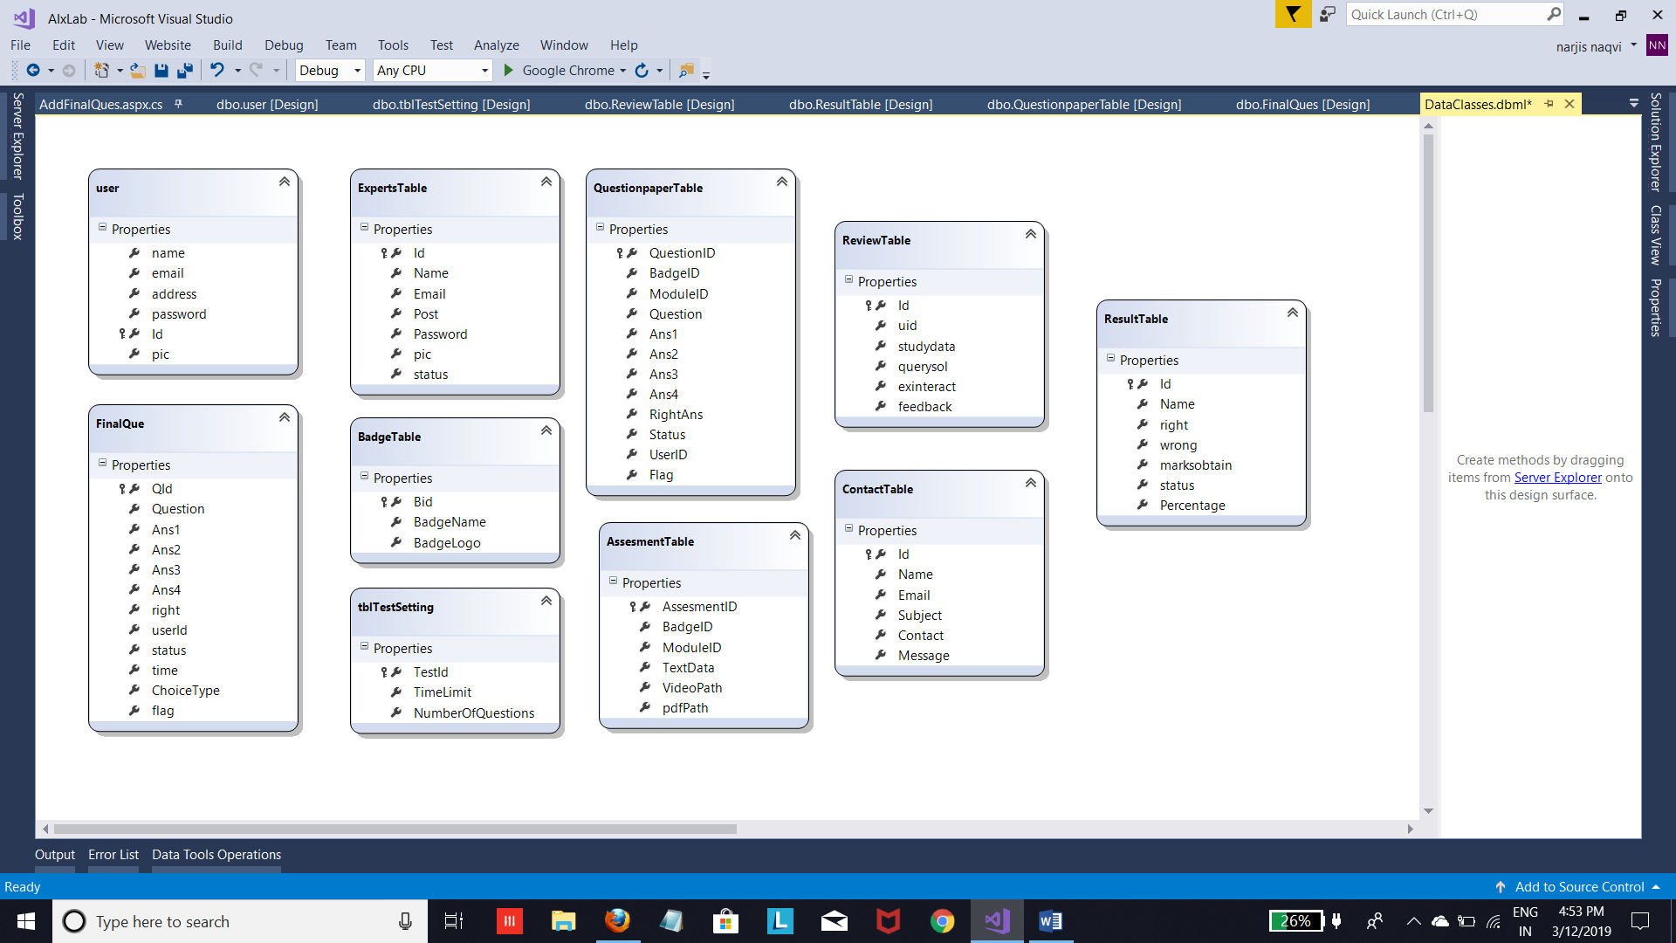

**Fig 6.1 Class Diagram**

## 6.2 USE CASE DIAGRAM

In the Unified Modeling Language (UML), a use case diagram can summarize the details of your system's users (also known as actors) and their interactions with the system. To build one, you'll use a set of specialized symbols and connectors. An effective use case diagram can help your team discuss and represent:

* Scenarios in which your system or application interacts with people, organizations, or external systems
* Goals that your system or application helps those entities (known as actors) achieve

**6.3 DATA FLOW DIAGRAM**

A data flow diagram (DFD) is a graphical representation of the "flow" of data through an information system, modeling its process aspects. Often they are a preliminary step used to create an overview of the system which can later be elaborated. DFDs can also be used for the visualization of data processing (structured design).

A DFD shows what kinds of information will be input to and output from the system, where the data will come from and go to, and where the data will be stored.

It does not show information about the timing of processes, or information about whether processes will operate in sequence or in parallel.

**Data Flow Diagram Symbols**

Data Flow Diagram symbols are standardized notations, like rectangles, circles, arrows, and short-text labels, that describe a system or process’ data flow direction, data inputs, data outputs, data storage points, and it’s various sub-processes.

The shapes and labels used to represent the four main elements of a DFD are -- **external entity, process, data store, and data flow.**

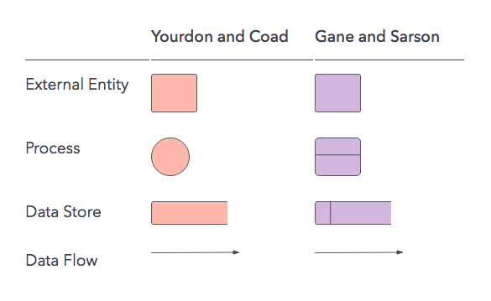

**Fig 6.2 DFD Shapes and Labels**

**1.External Entity-** An external entity, which are also known as terminators, sources, sinks, or actors, are an outside system or process that sends or receives data to and from the diagrammed system. They’re either the sources or destinations of information, so they’re usually placed on the diagram’s edges.

**2. Process-** Process is a procedure that manipulates the data and its flow by taking incoming data, changing it, and producing an output with it. A process can do this by performing computations and using logic to sort the data or change its flow of direction. Processes usually start from the top left of the DFD and finish on the bottom right of the diagram.

**3. Data Store-** Data stores hold information for later use, like a file of documents that’s waiting to be processed. Data inputs flow through a process and then through a data store while data outputs flow out of a data store and then through a process.

**4. Data flow-** Data flow is the path the system’s information takes from external entities through processes and data stores. With arrows and succinct labels, the DFD can show you the direction of the data flow.

**Data flow diagram levels**

Data flow diagrams are also categorized by level. Starting with the most basic, level 0, DFDs get increasingly complex as the level increases. As you build your own data flow diagram, you will need to decide which level your diagram will be.

**Level 0 DFDs**, also known as context diagrams, are the most basic data flow diagrams. They provide a broad view that is easily digestible but offers little detail. Level 0 data flow diagrams show a single process node and its connections to external entities.

**Level 1 DFDs** are still a general overview, but they go into more detail than a context diagram. In a level 1 data flow diagram, the single process node from the context diagram is broken down into sub processes. As these processes are added, the diagram will need additional data flows and data stores to link them together.

**Level 2 DFDs** simply break processes down into more detailed sub processes. In theory, DFDs could go beyond level 3, but they rarely do. Level 3 data flow diagrams are detailed enough that it doesn’t usually make sense to break them down further.

**DATA FLOW DIAGRAM OF PROJECT:**

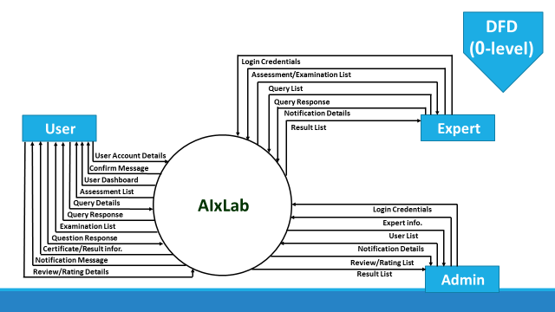

**Fig 6.3 ZERO LEVEL DFD**

**5.3 1st Level DFD**

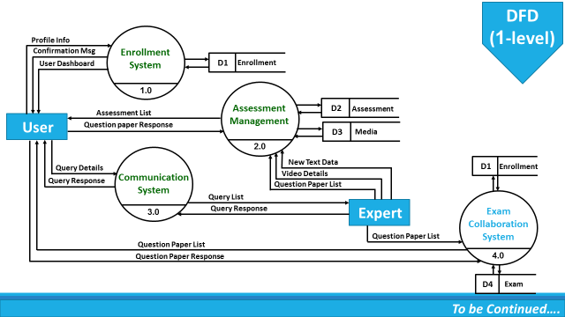

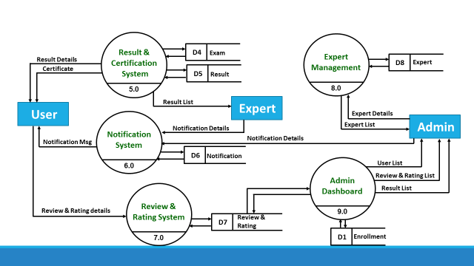

**Fig 6.4 ONE LEVEL DFD**

**ER DIAGRAM**

## What is an ER diagram?

An Entity Relationship (ER) Diagram is a type of flowchart that illustrates how “entities” such as people, objects or concepts relate to each other within a system. ER Diagrams are most often used to design or debug relational databases in the fields of software engineering, business information systems, education and research. Also known as ERDs or ER Models, they use a defined set of symbols such as rectangles, diamonds, ovals and connecting lines to depict the interconnectedness of entities, relationships and their attributes. They mirror grammatical structure, with entities as nouns and relationships as verbs.

ER diagrams are related to data structure diagrams (DSDs), which focus on the relationships of elements within entities instead of relationships between entities themselves. ER diagrams also are often used in conjunction with data flow diagrams (DFDs), which map out the flow of information for processes or systems.

**The components and features of an ER diagram**

ER Diagrams are composed of entities, relationships and attributes. They also depict cardinality, which defines relationships in terms of numbers. Here’s a glossary:

**Entity:**

A definable thing such as a person, object, concept or event that can have data stored about it. Think of entities as nouns. Examples: a customer, student, car or product. Typically shown as a rectangle.

**Relationship:**

How entities act upon each other or are associated with each other. Think of relationships as verbs. For example, the named student might register for a course. The two entities would be the student and the course, and the relationship depicted is the act of enrolling, connecting the two entities in that way. Relationships are typically shown as diamonds or labels directly on the connecting lines.

**Attribute:**

A property or characteristic of an entity. Often shown as an oval or circle.

**Cardinality:**

Defines the numerical attributes of the relationship between two entities or entity sets. The three main cardinal relationships are one-to-one, one-to-many, and many-many. **A one-to-one** example would be one student associated with one mailing address. A **one-to-many example** (or many-to-one, depending on the relationship direction): One student registers for multiple courses, but all those courses have a single line back to that one student. **Many-to-many example**: Students as a group are associated with multiple faculty members, and faculty members in turn are associated with multiple students.

**One-to-one**

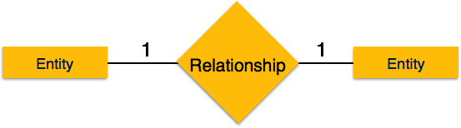

**One-to-Many**

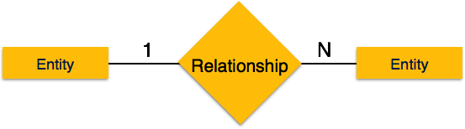

**Many-to-Many**

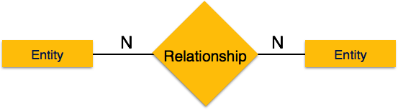

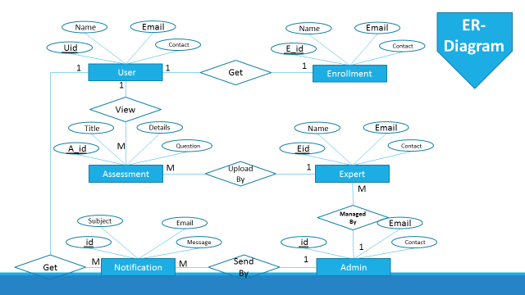

**Fig 6.5 ER DIAGRAM OF AIX LAB**

**6.4 DATABASE TABLES**

* + 1. **Assessment Table**

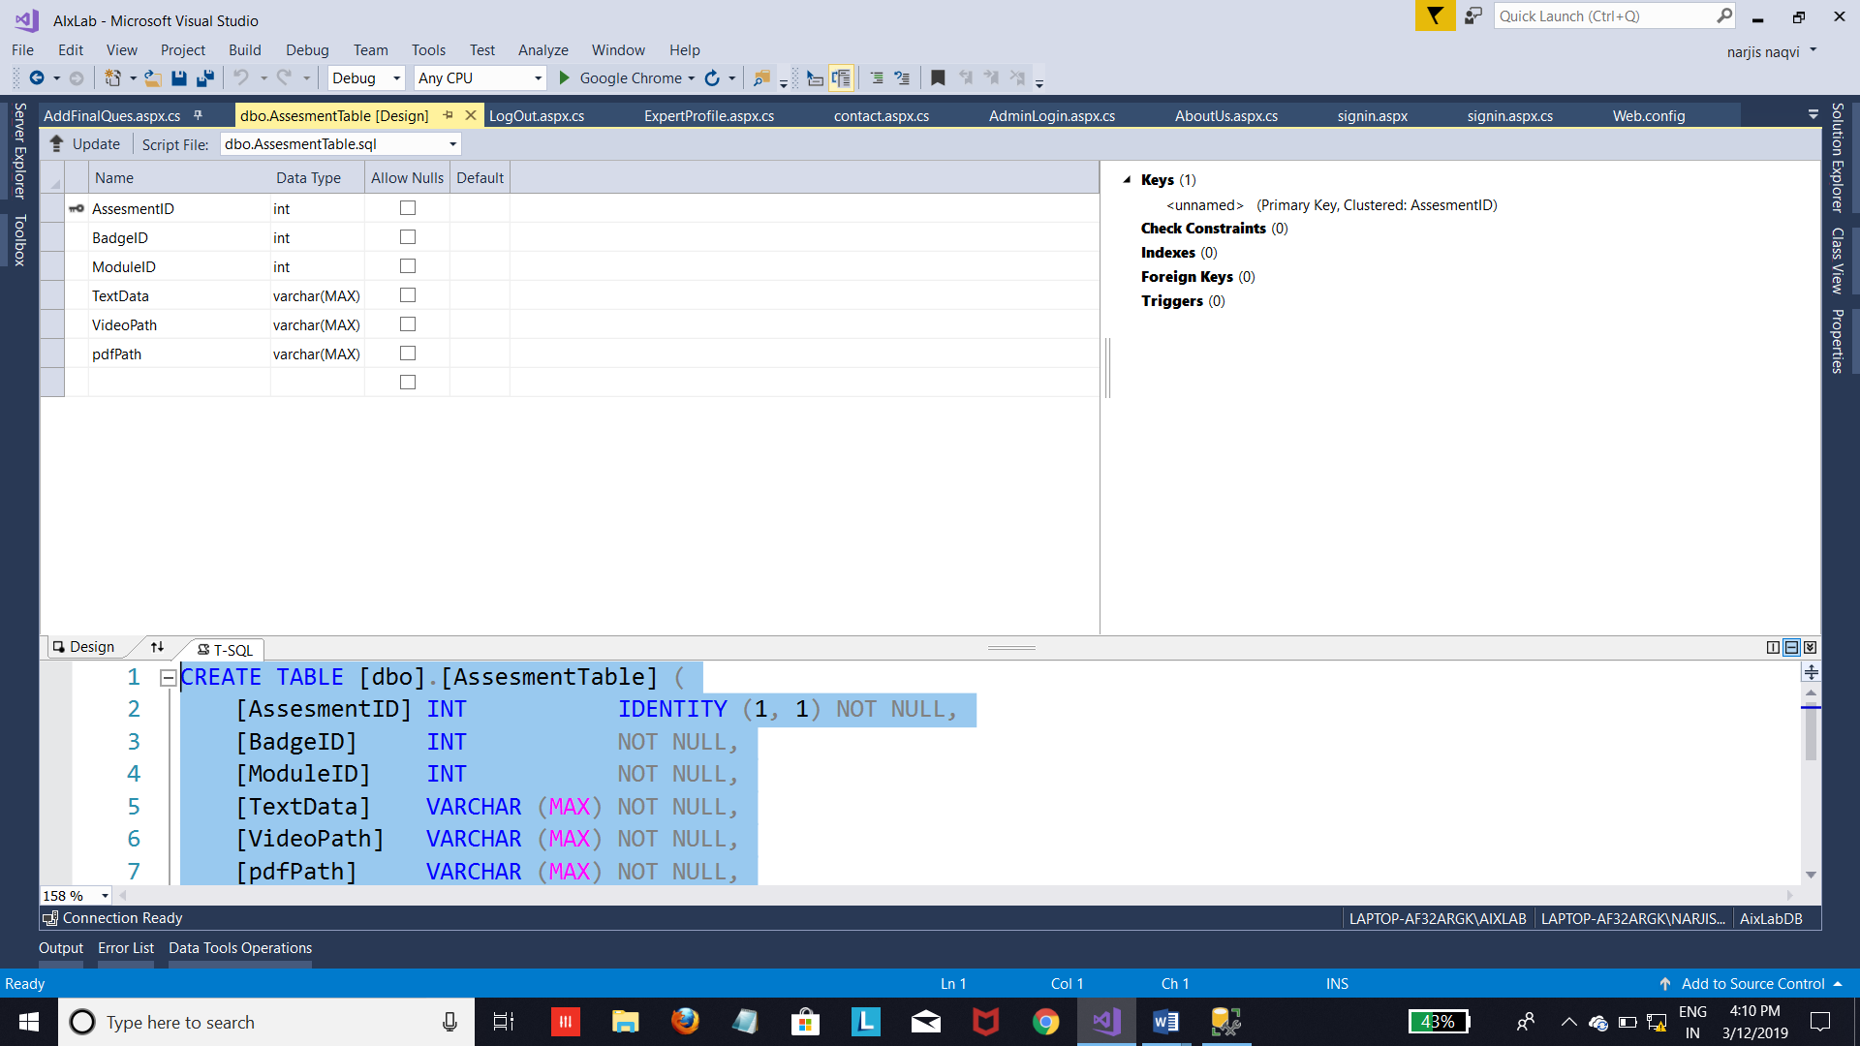

* + 1. **Badge Table**

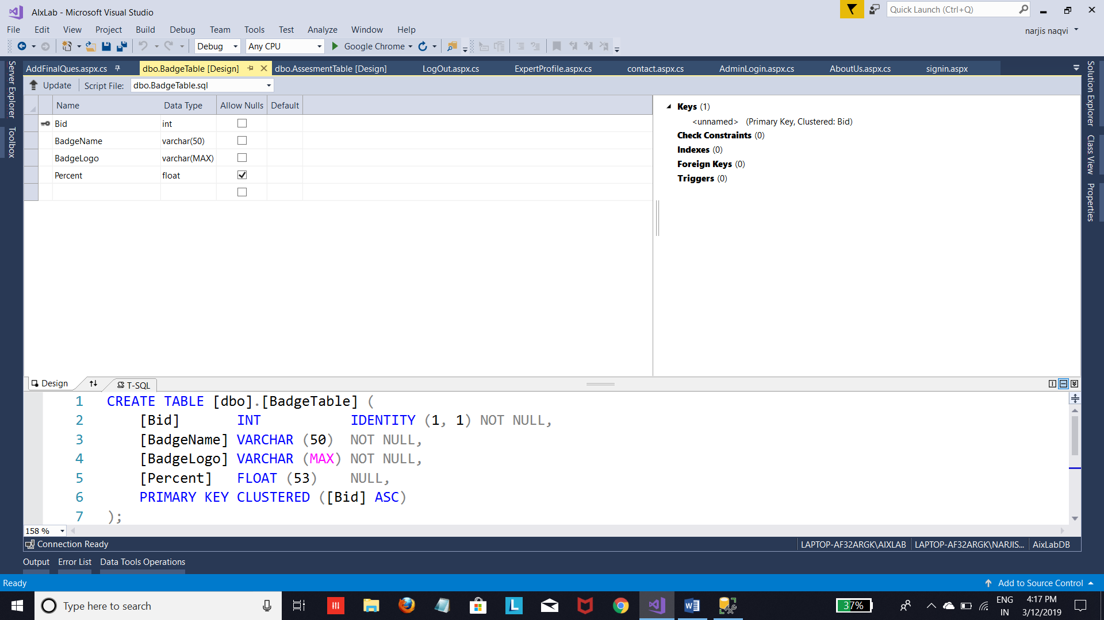

* + 1. **Contact Table**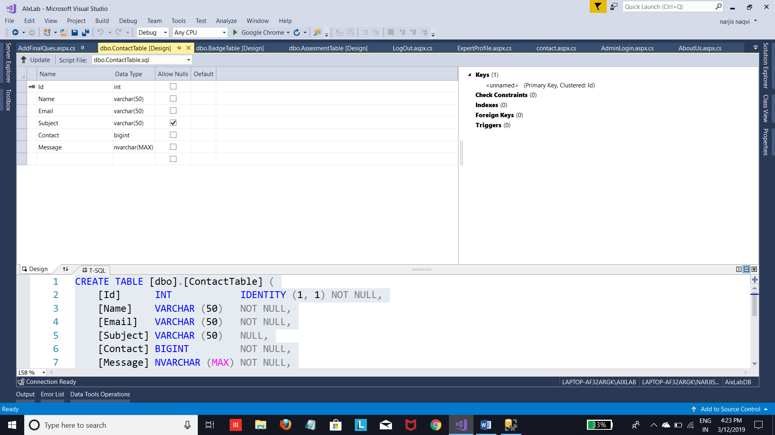
    2. **Expert Table**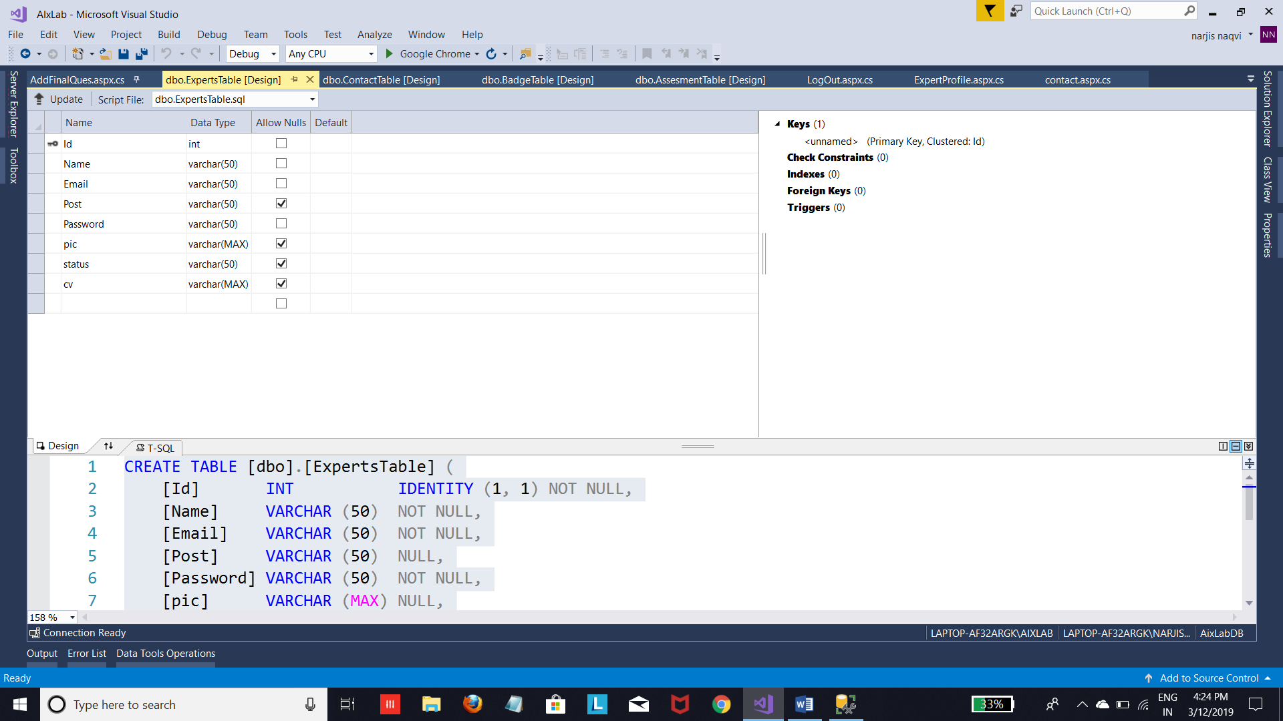
    3. **Final Question Paper**

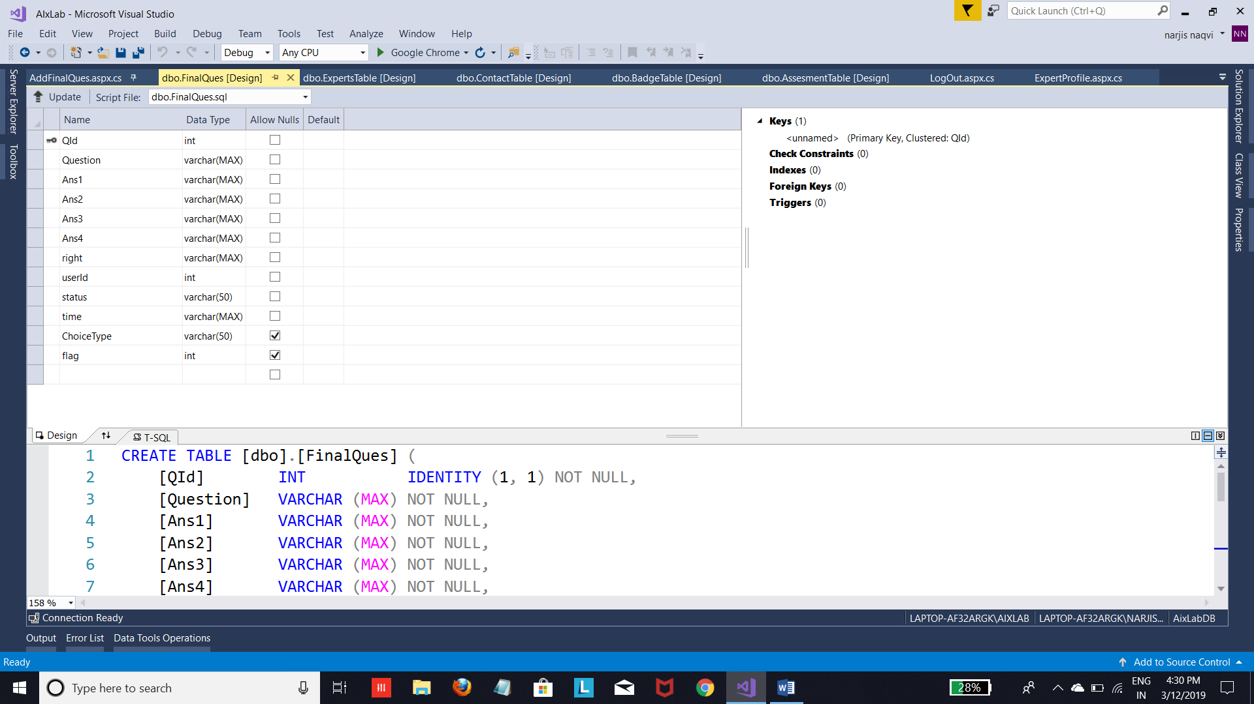

* + 1. **Question Paper Table**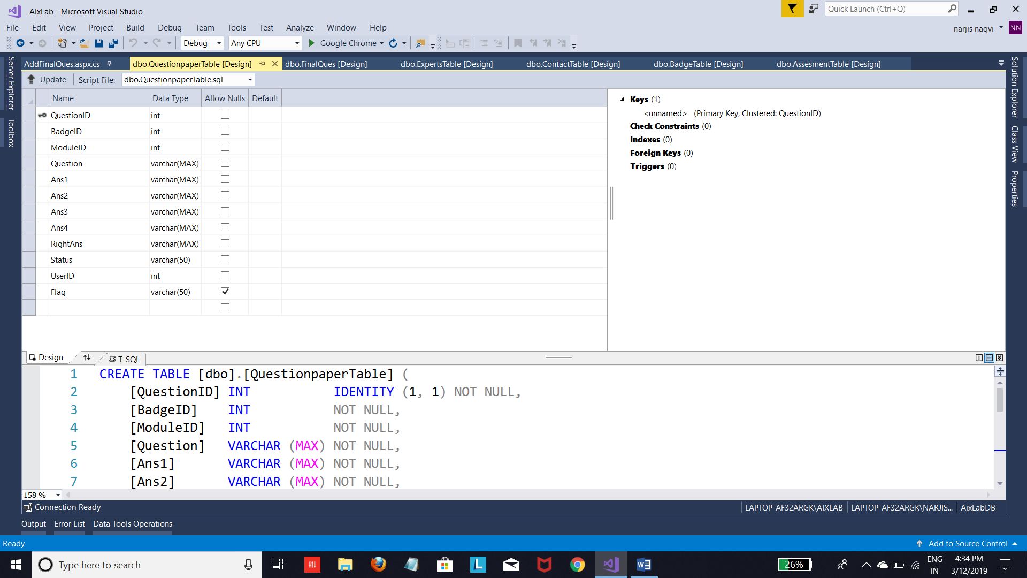
  1. **Result Table**

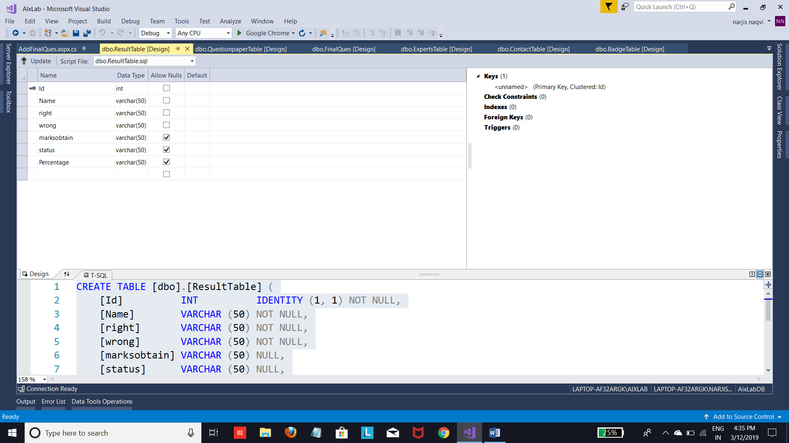

* 1. **Review Table**

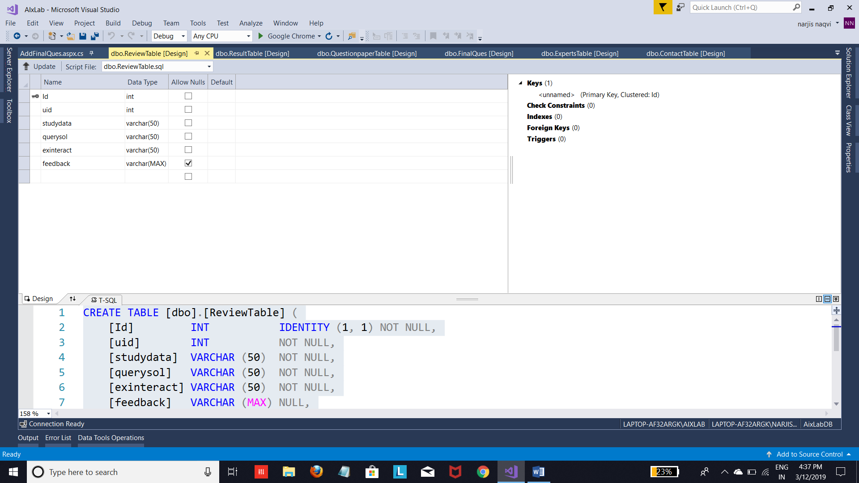

* 1. **Test Table Setting**

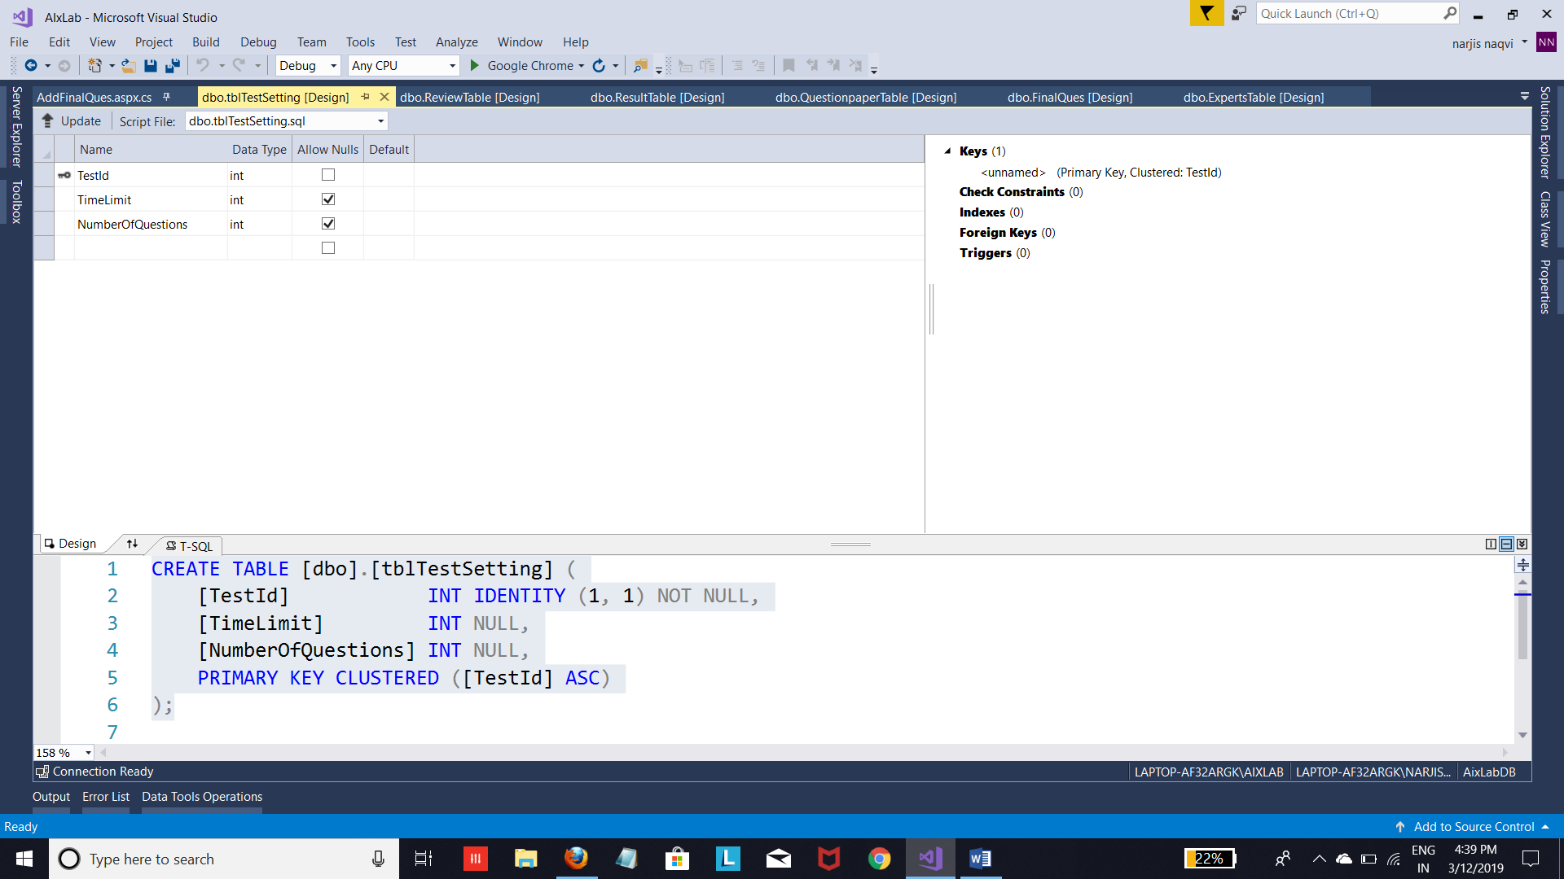

* 1. **User Table**

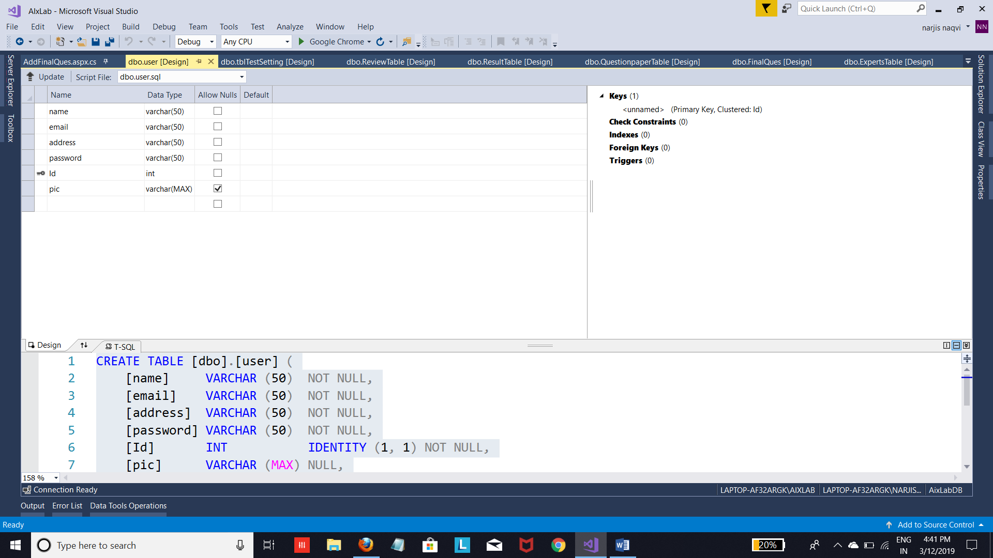

**Chapter – 7**

**SNAPSHOTS**

**7.1 Default page**

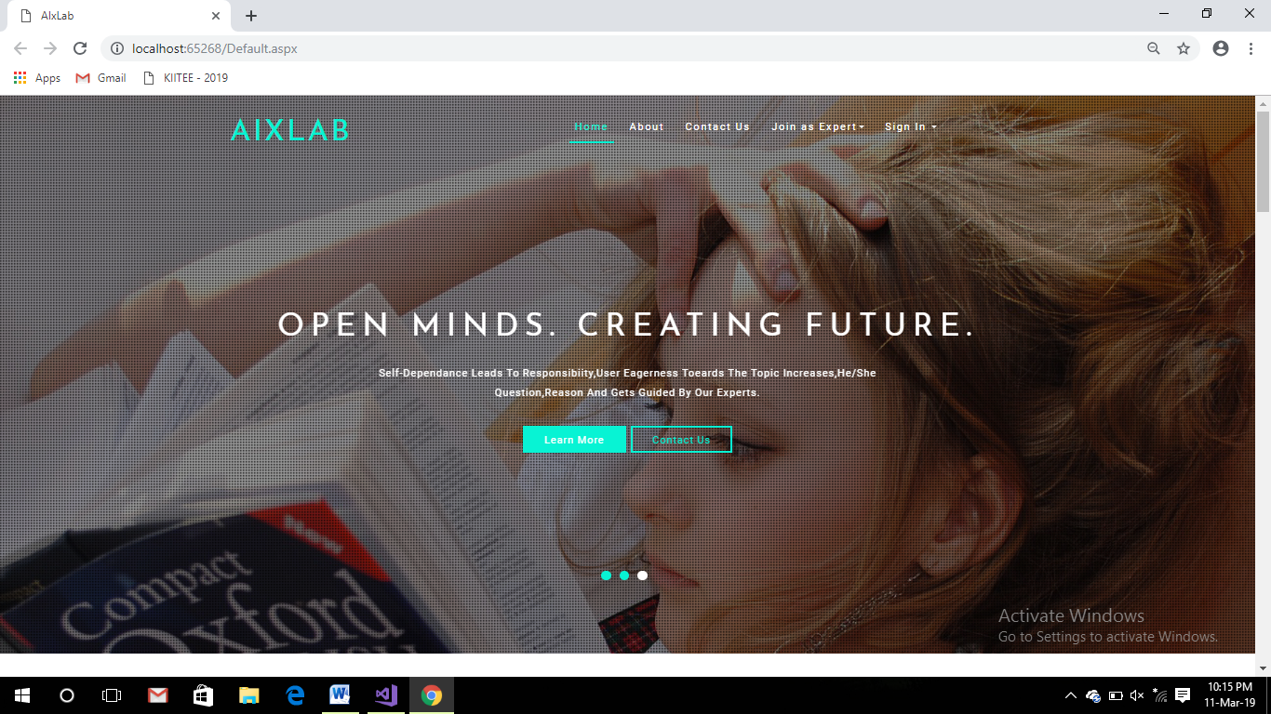

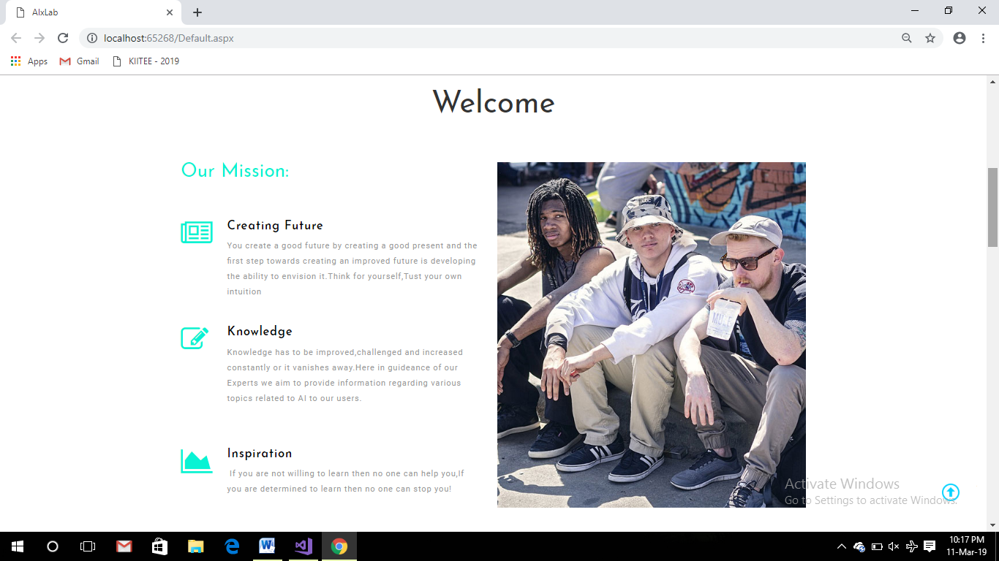

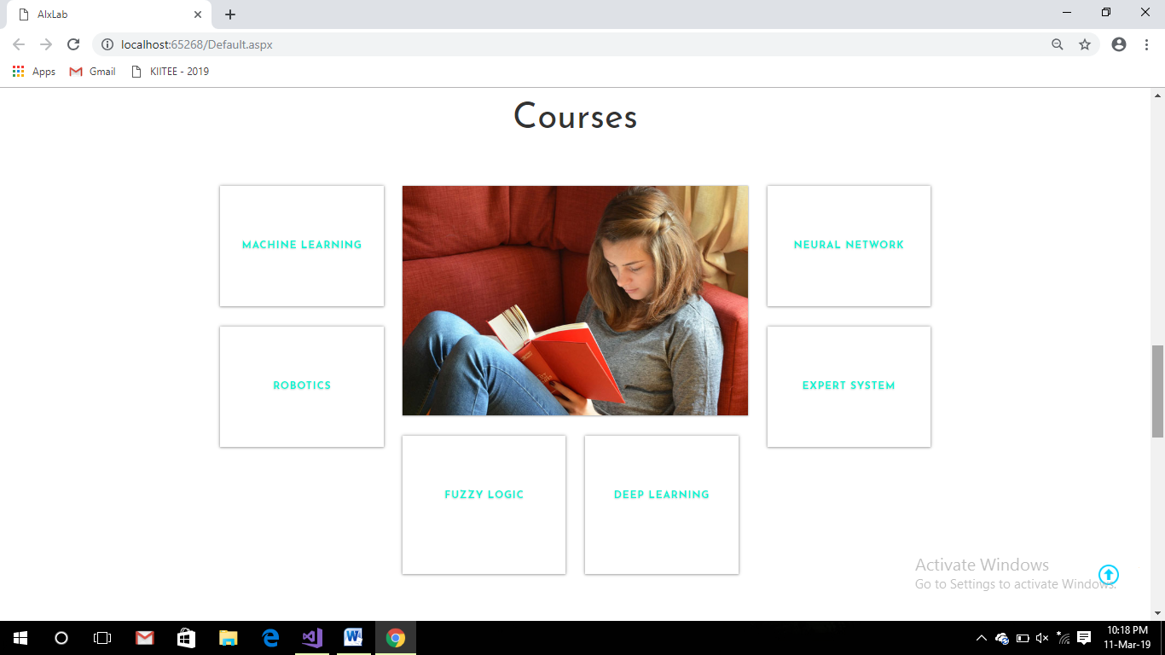

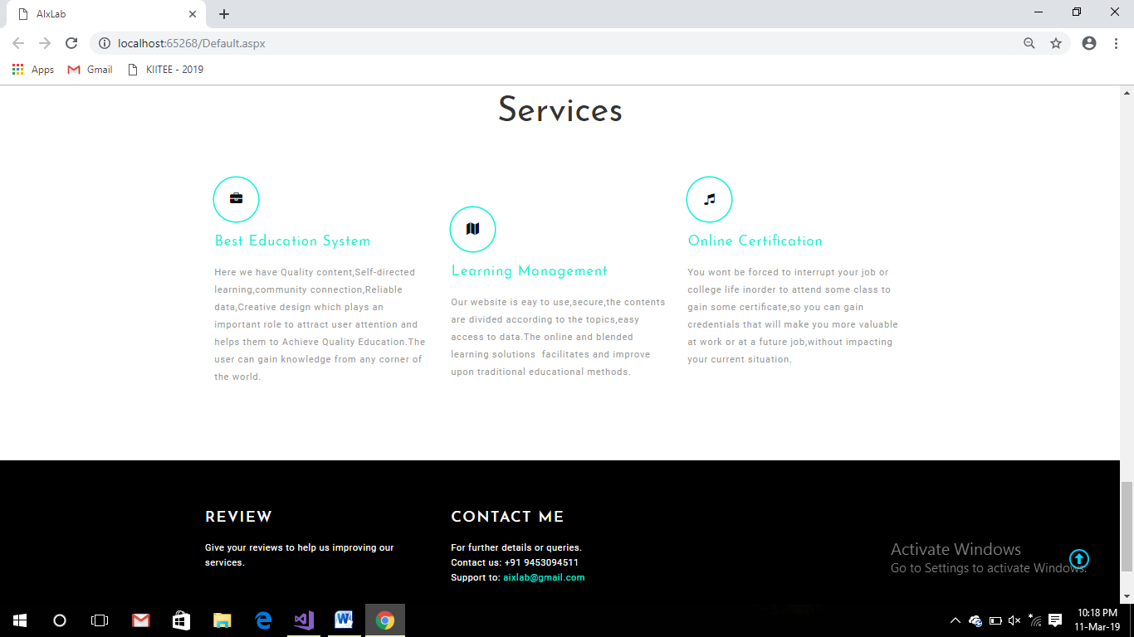

**7.2 About**

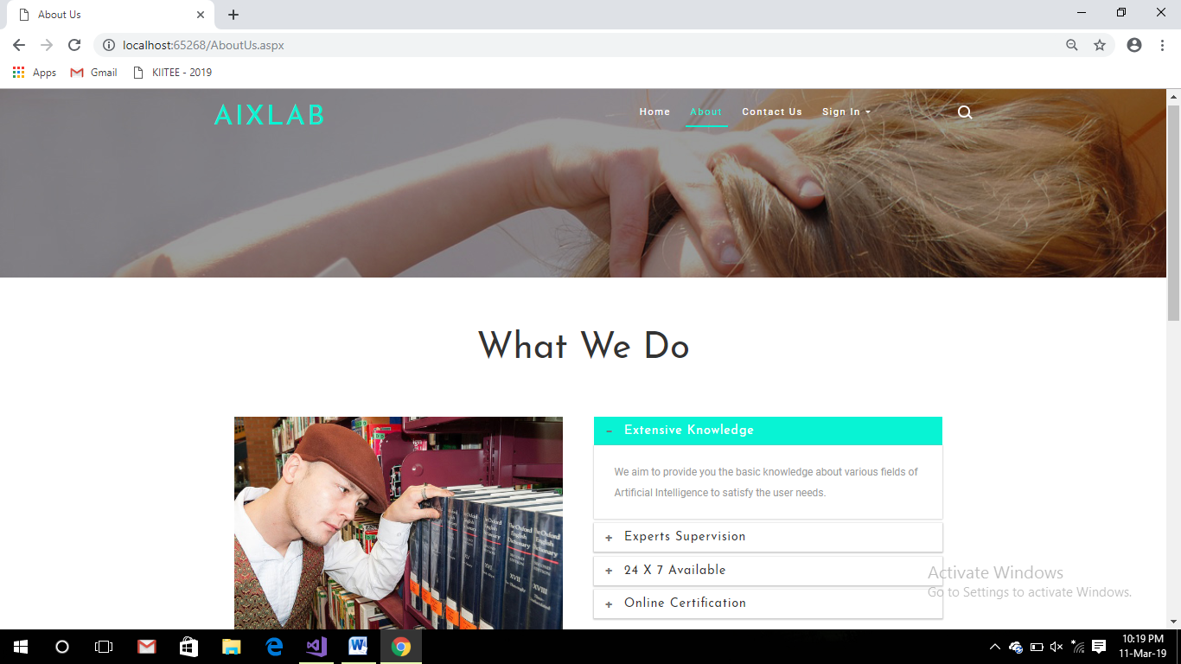

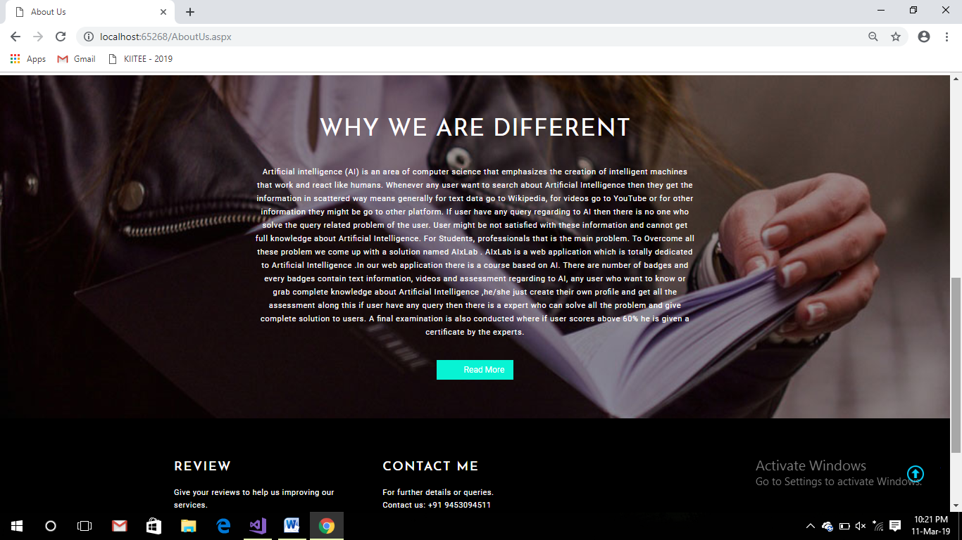

**7.3 Contact Us**

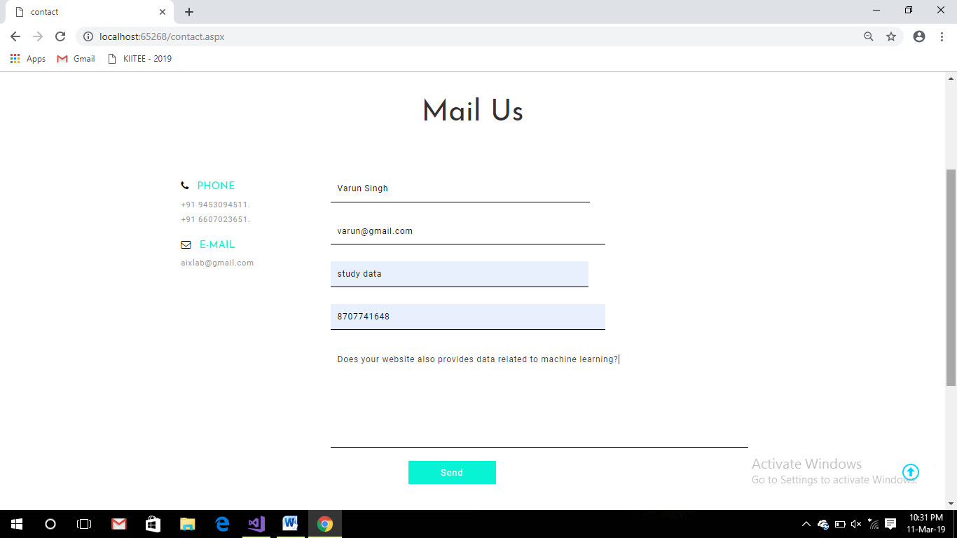

# User Panel

**7.4 User Sign Up**

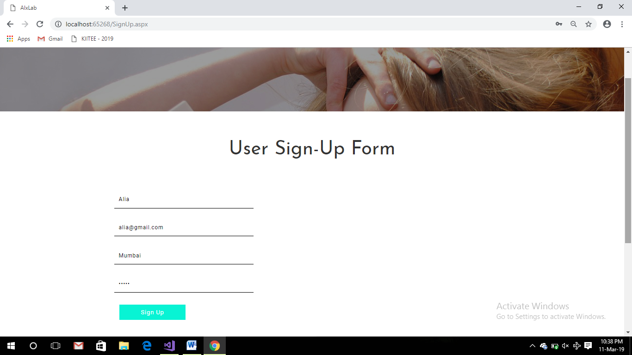

**7.5 User Sign In**

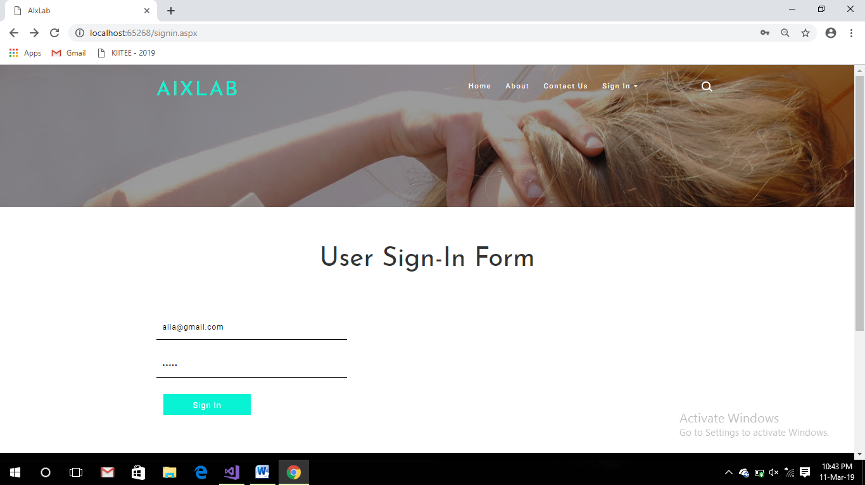

**7.6 User Home**

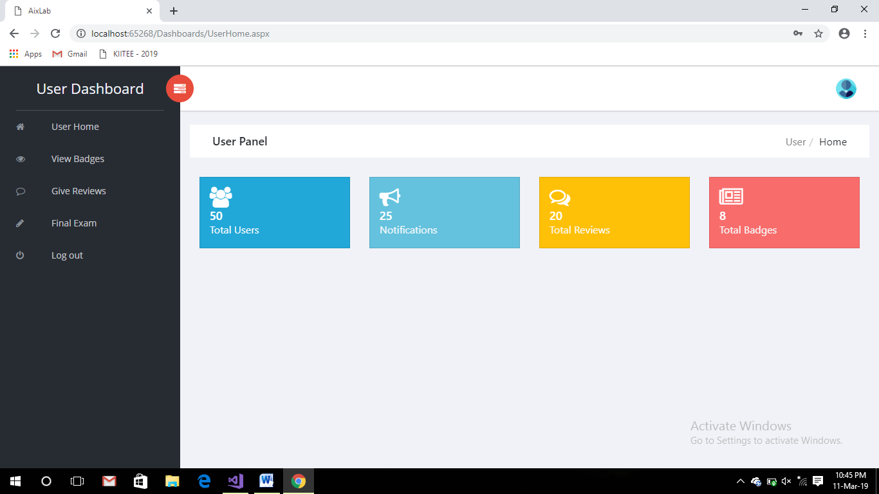

**7.7 View Badges**

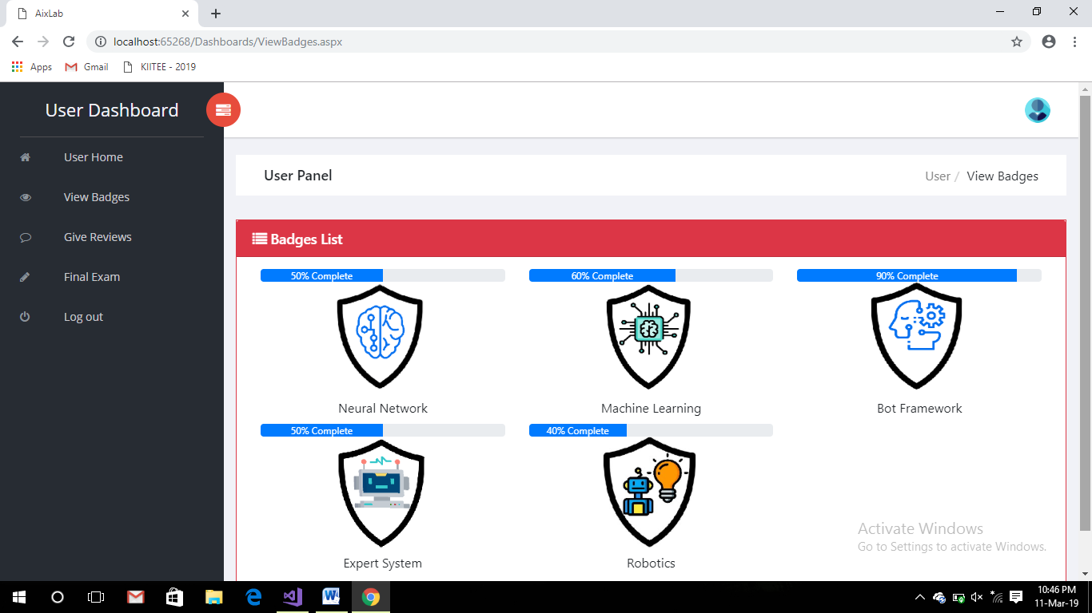

**7.8 Study modules**

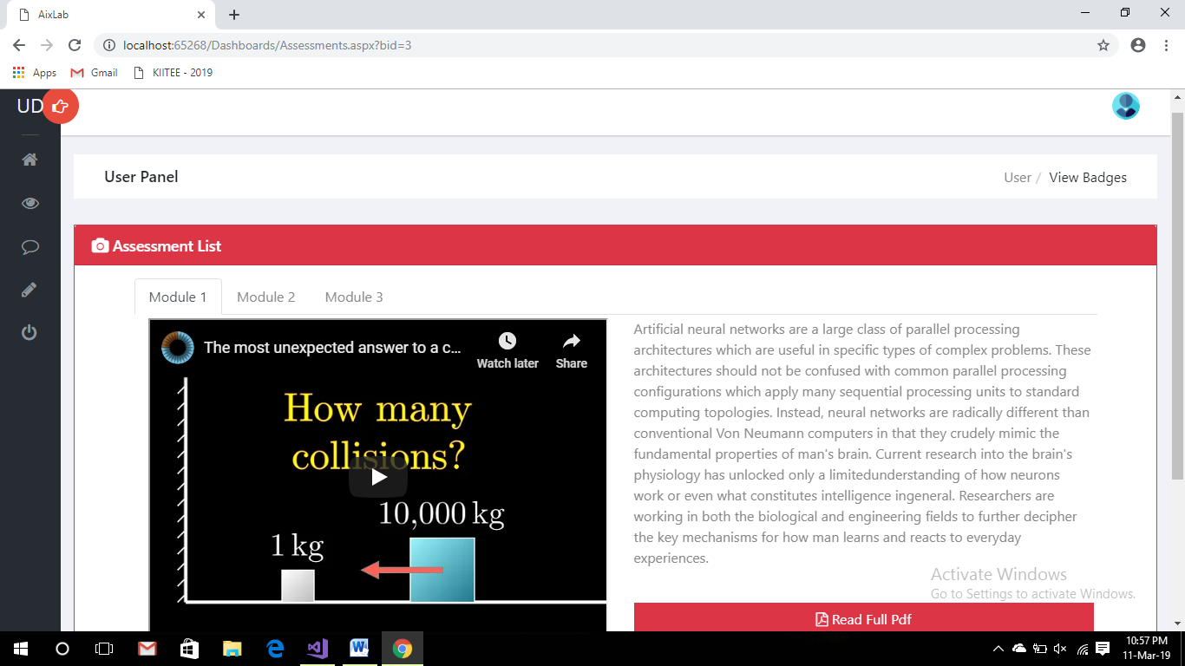

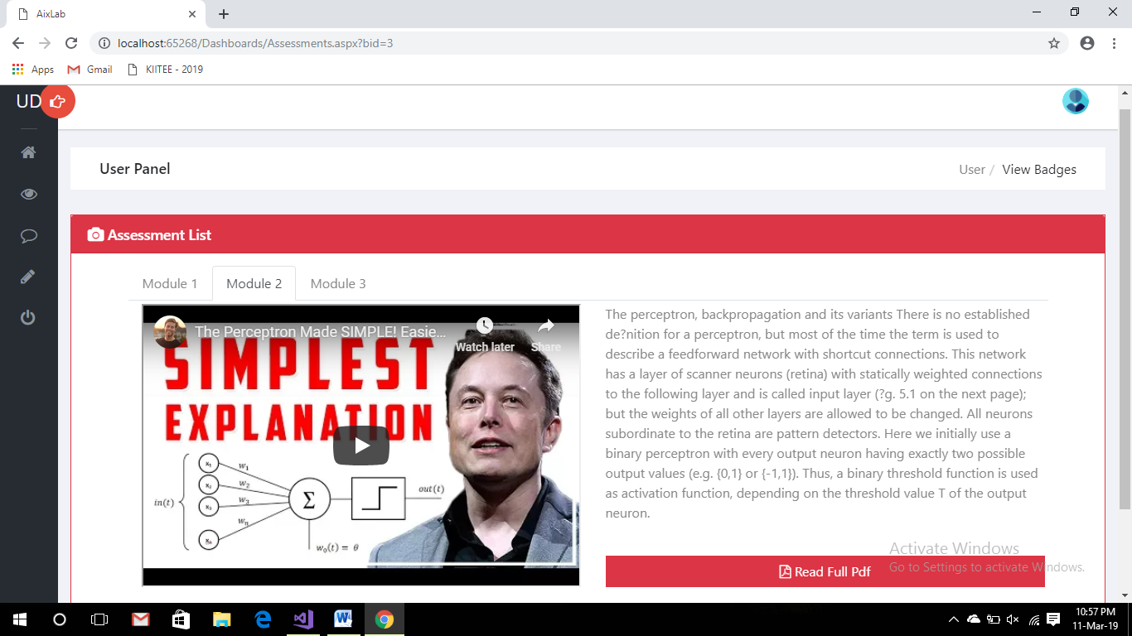

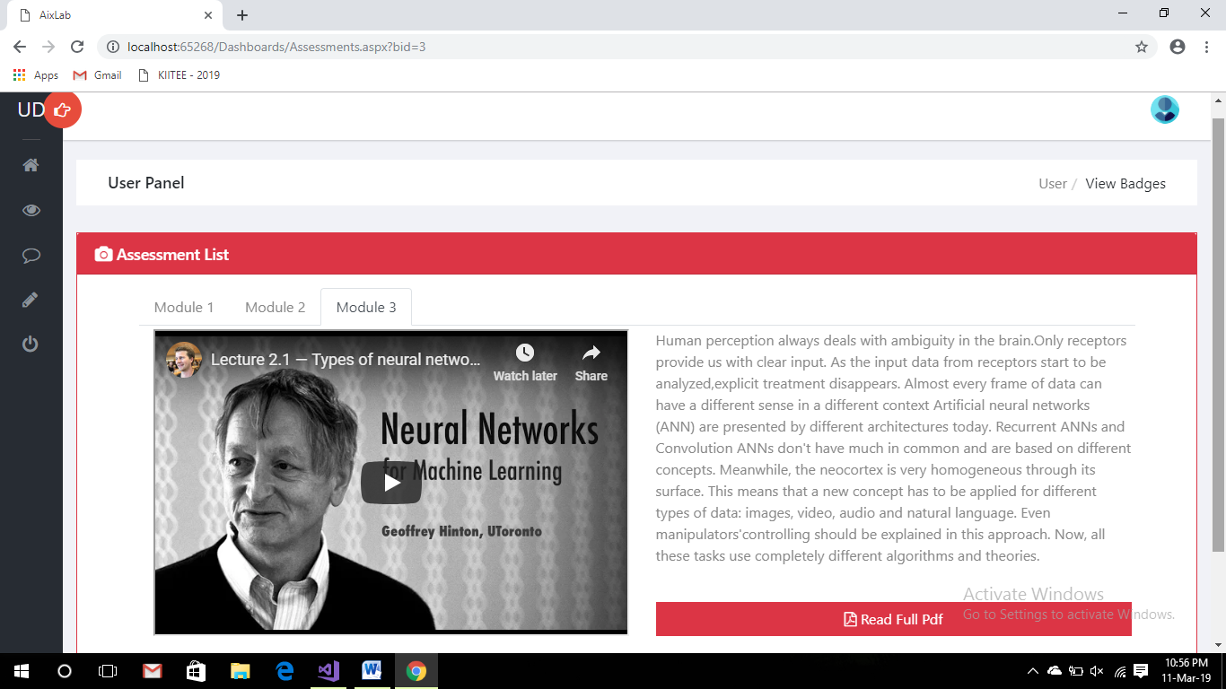

**7.9 Modules test**

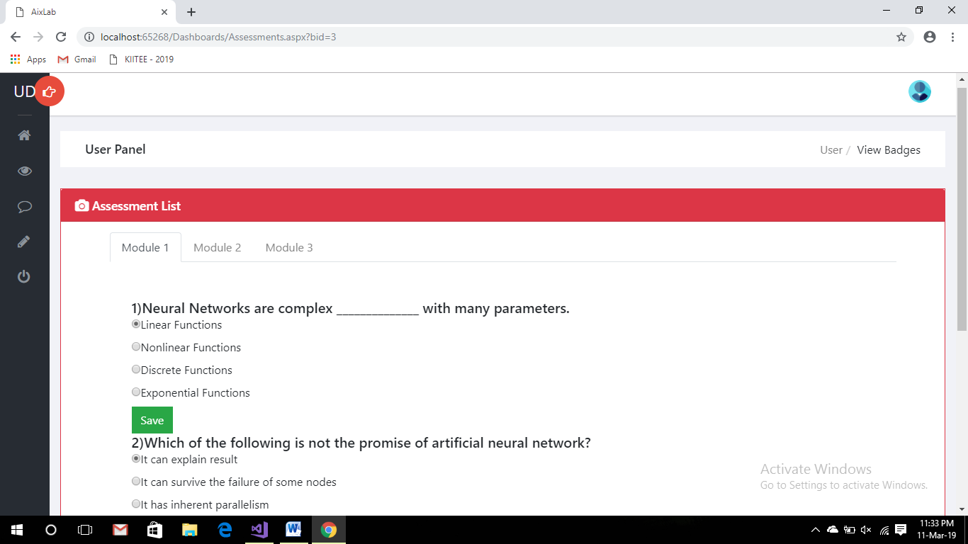

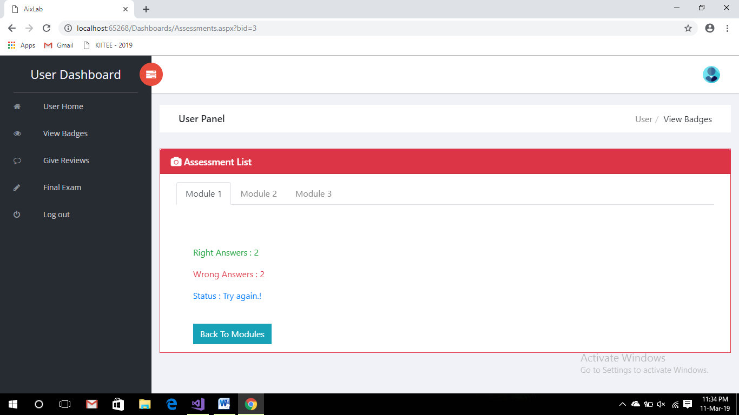

**7.10 Give Reviews**

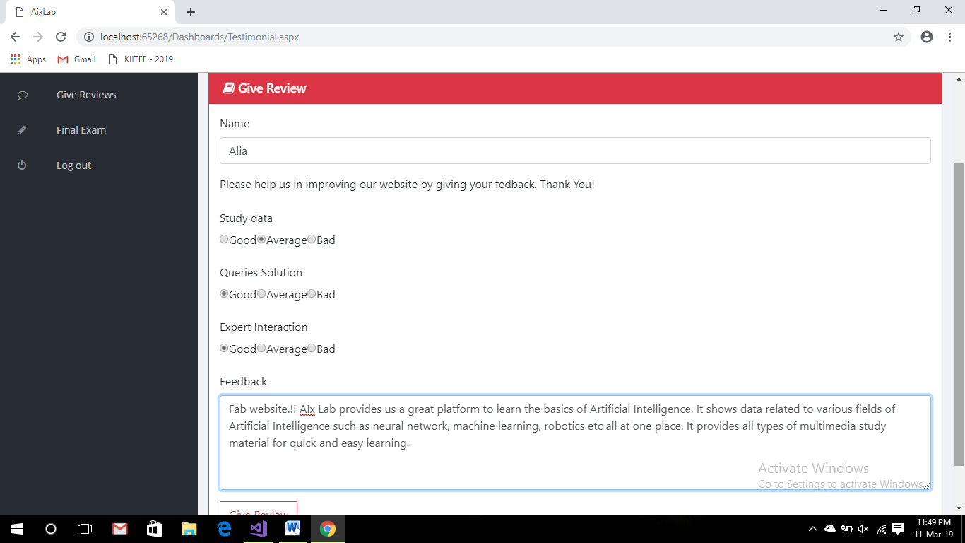

**7.11 My profile**

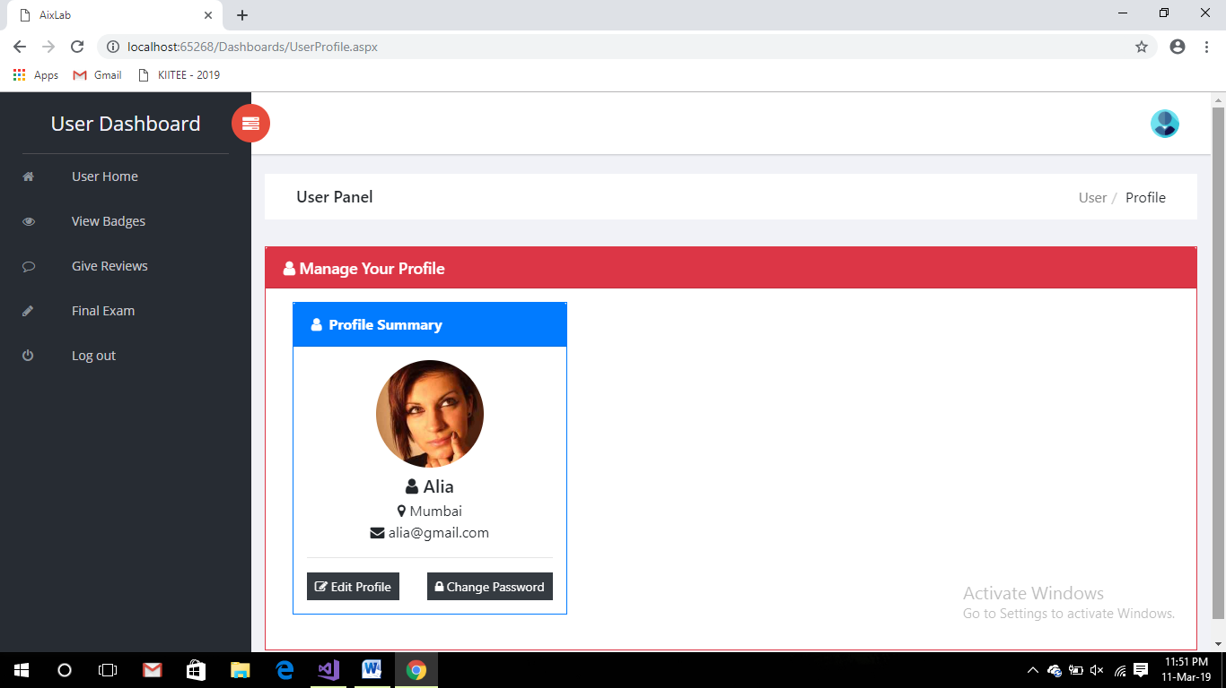

**7.12 Edit profile**

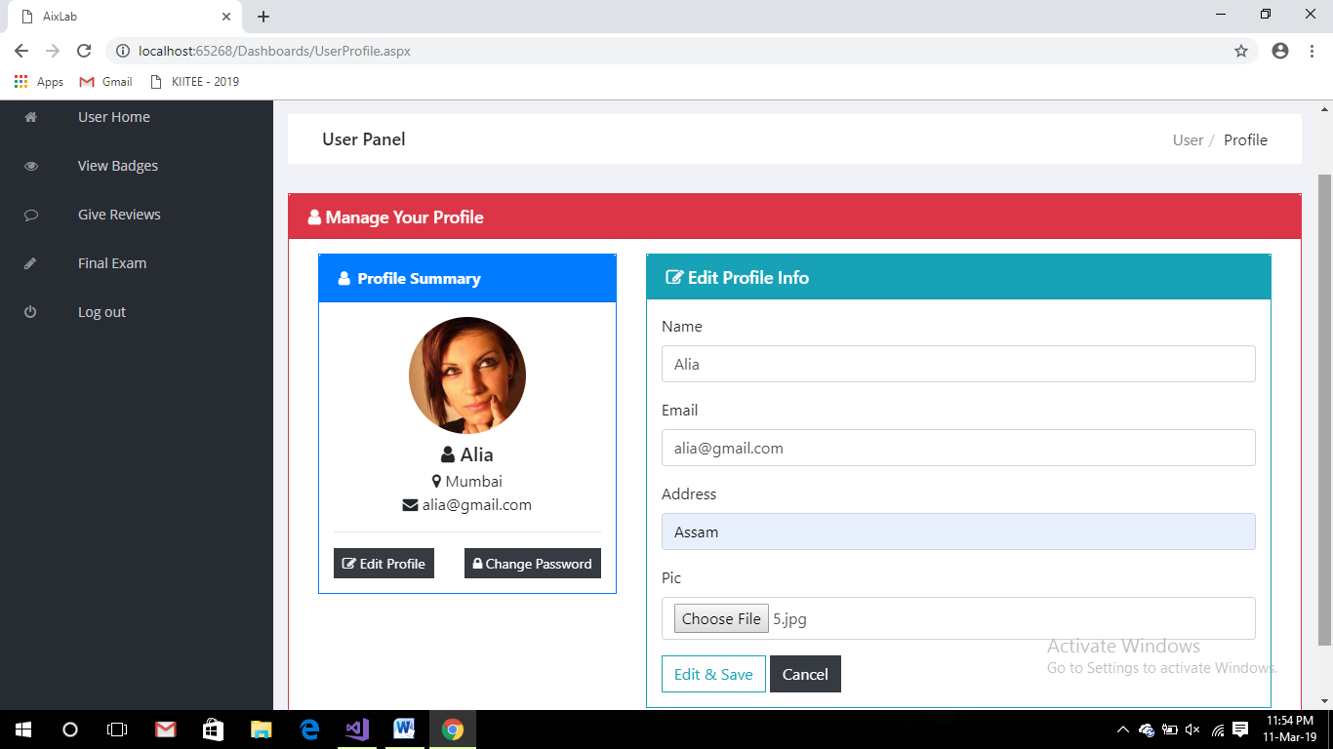

**7.13 Change Password**

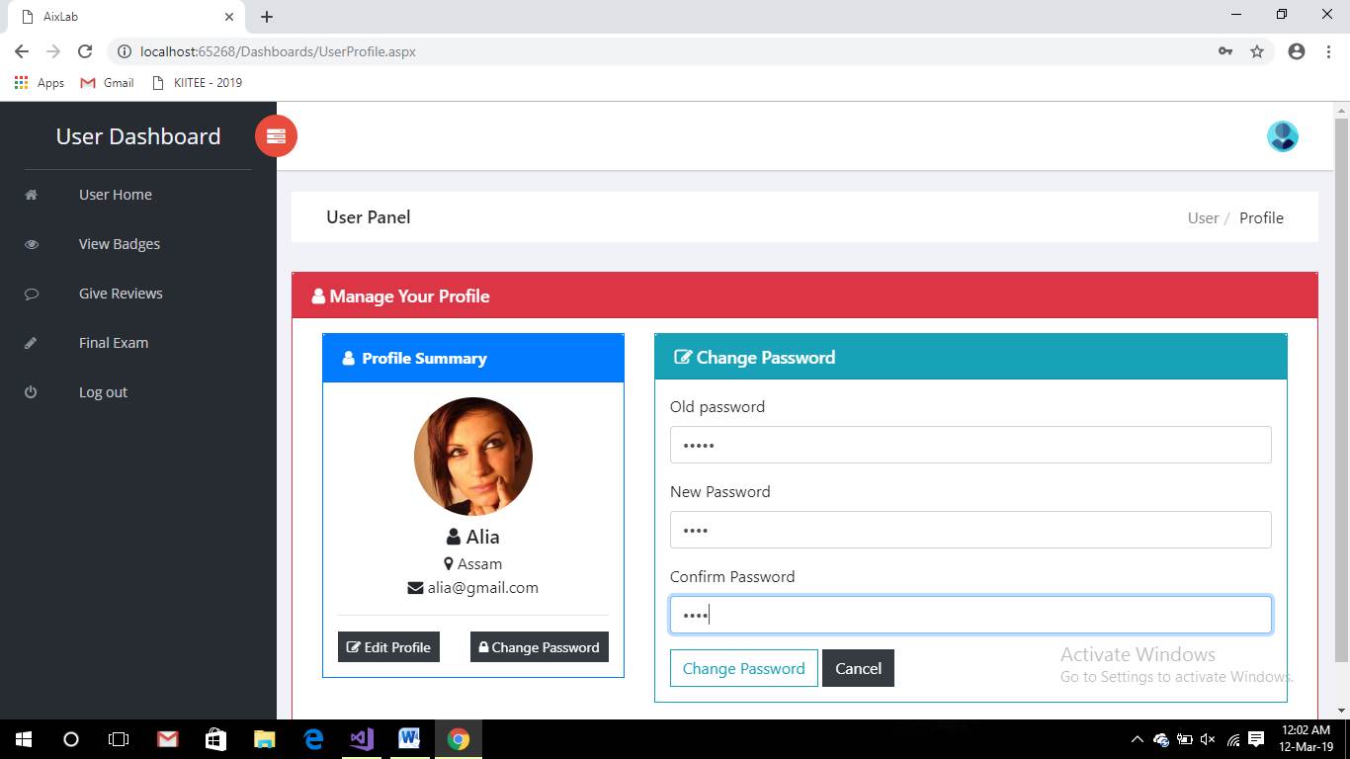

**7.14 Final Examination**

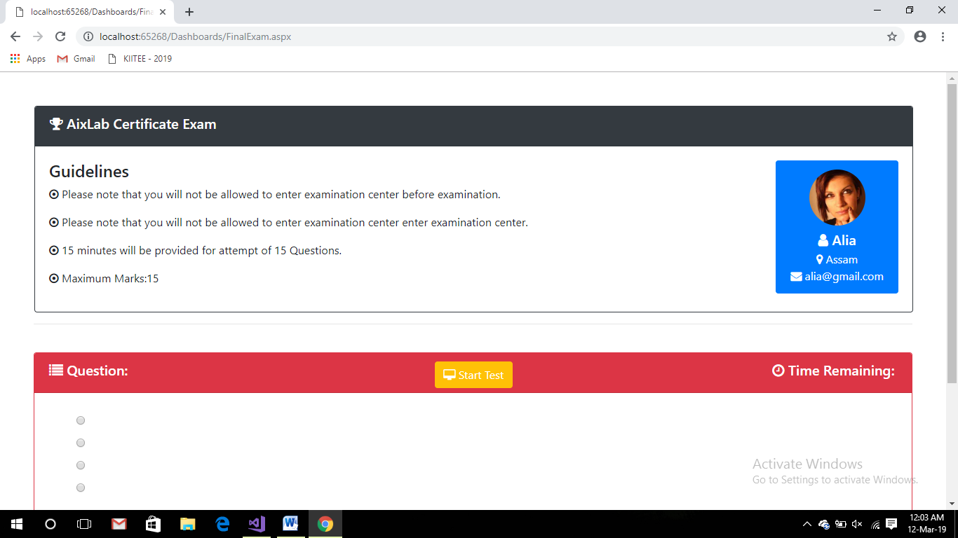

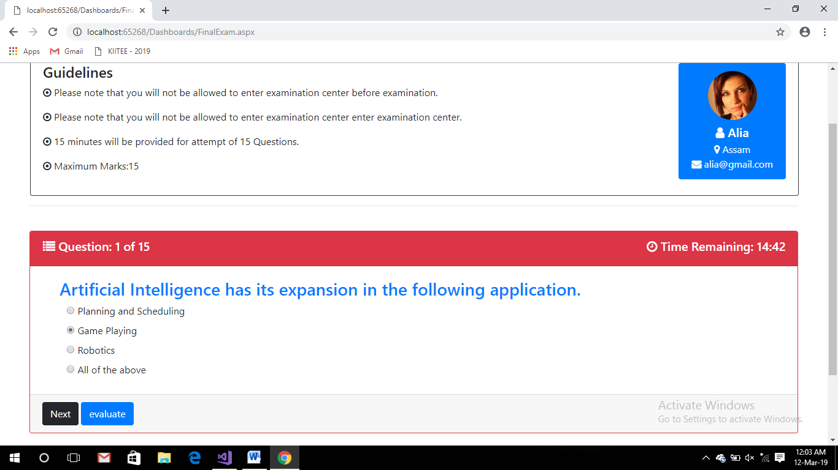

**7.15 Result**

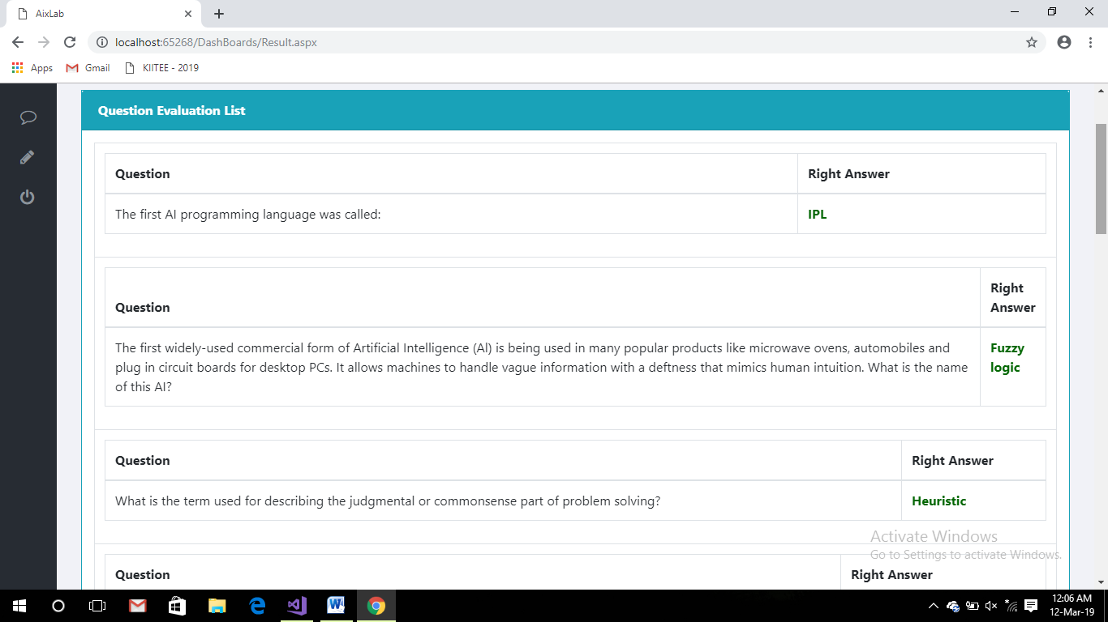

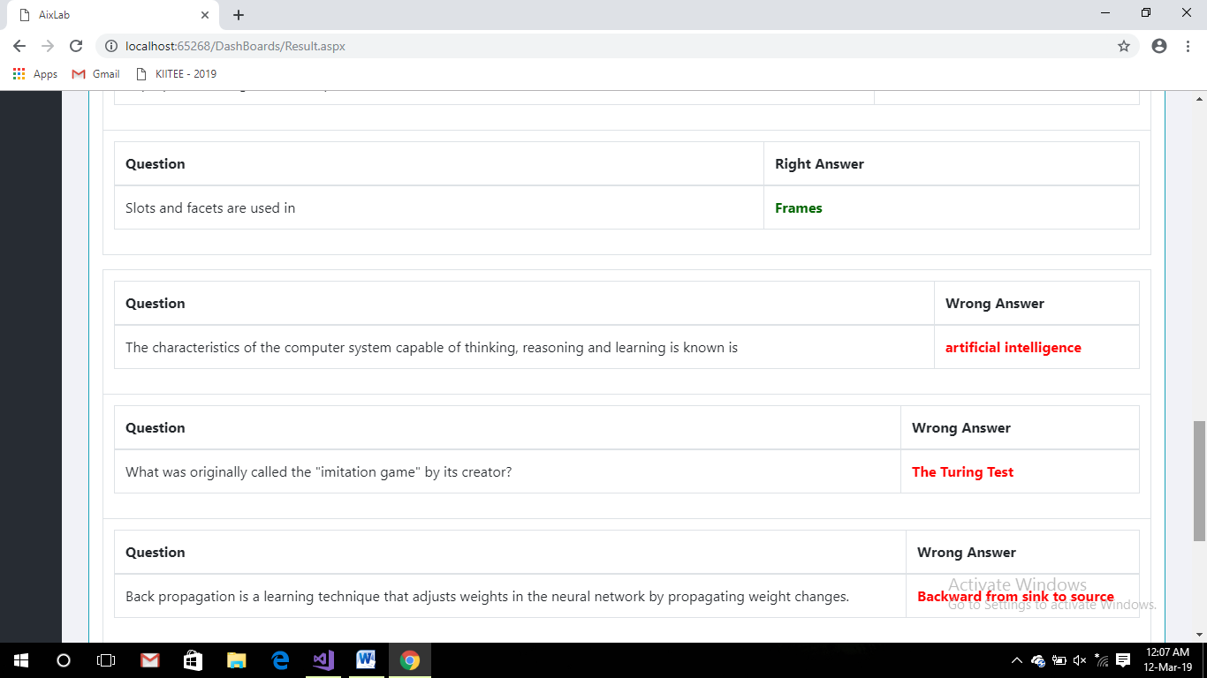

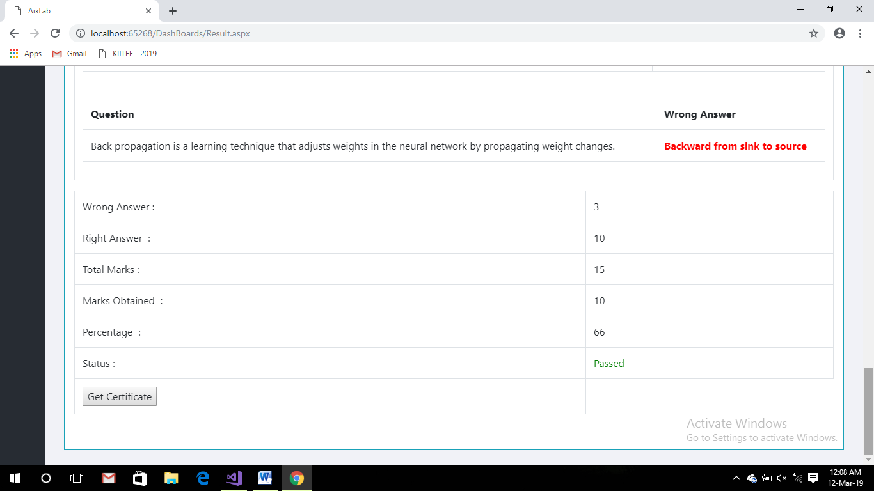

**Chapter – 8**

**CODING**

**1) Admin Dashboard**

<%@ Master Language="C#" AutoEventWireup="true" CodeFile="AdminMaster.master.cs" Inherits="Dashboards_AdminMaster" %>

<!DOCTYPE html>

<html>

<head>

<title>AIxLab:Admin Panel</title>

<link rel="apple-touch-icon" href="apple-icon.png">

<link rel="shortcut icon" href="favicon.ico">

<link rel="stylesheet" href="assets/css/normalize.css">

<link rel="stylesheet" href="assets/css/bootstrap.min.css">

<link rel="stylesheet" href="assets/css/font-awesome.min.css">

<link rel="stylesheet" href="assets/css/themify-icons.css">

<link rel="stylesheet" href="assets/css/flag-icon.min.css">

<link rel="stylesheet" href="assets/css/cs-skin-elastic.css">

<link rel="stylesheet" href="assets/css/bootstrap-select.less">

<link rel="stylesheet" href="assets/scss/style.css">

</head>

<body>

<aside id="left-panel" class="left-panel">

<nav class="navbar navbar-expand-sm navbar-default">

<div class="navbar-header">

<button class="navbar-toggler" type="button" data-toggle="collapse" data-target="#main-menu" aria-controls="main-menu" aria-expanded="false" aria-label="Toggle navigation">

<i class="fa fa-bars"></i>

</button>

<a class="navbar-brand" href="./">AIxLab Dashboard</a>

<a class="navbar-brand hidden" href="./">AI</a>

</div>

<div id="main-menu" class="main-menu collapse navbar-collapse">

<ul class="nav navbar-nav">

<li>

<a href="AdminHome.aspx"><i class="menu-icon fa fa-home"></i>Admin Home </a>

</li>

<li>

<a href="ViewUsers.aspx"><i class="menu-icon fa fa-users"></i>View Users </a>

</li>

<li>

<a href="ViewExpert.aspx"><i class="menu-icon fa fa-user"></i>View Experts </a>

</li>

<li>

<a href="ApproveExpert.aspx"><i class="menu-icon fa fa-user-plus"></i>Approve Experts</a>

</li>

<li>

<a href="Viewresult.aspx"><i class="menu-icon fa fa-list"></i>View Result </a>

</li>

<li>

<a href="SendNotification.aspx"><i class="menu-icon fa fa-bullhorn"></i>Send Notifications </a>

</li>

<li>

<a href="ViewReview.aspx"><i class="menu-icon fa fa-comment-o"></i>View Reviews</a>

</li>

<li>

<a href="../LogOut.aspx"><i class="menu-icon fa fa-power-off"></i>Log out </a>

</li>

</ul>

</div>

</nav>

</aside>

<div id="right-panel" class="right-panel">

<header id="header" class="header">

<div class="header-menu">

<div class="col-sm-7">

<a id="menuToggle" class="menutoggle pull-left"><i class="fa fa fa-tasks"></i></a>

</div>

<div class="col-sm-5">

<div class="user-area dropdown float-right">

<a href="#" class="dropdown-toggle" data-toggle="dropdown" aria-haspopup="true" aria-expanded="false">

<img class="user-avatar rounded-circle" src="../images/ts2.jpg" alt="User Avatar">

</a>

</div>

</div>

</div>

</header>

<div class="content mt-3">

<div class="animated fadeIn">

<asp:ContentPlaceHolder ID="ContentPlaceHolder2" runat="server"></asp:ContentPlaceHolder>

</div>

</div>

</div>

<script src="assets/js/vendor/jquery-2.1.4.min.js"></script>

<script src="assets/js/popper.min.js"></script>

<script src="assets/js/plugins.js"></script>

<script src="assets/js/main.js"></script>

</body>

</html>

**2) Expert Dashboard**

<!DOCTYPE html>

<html>

<head>

<title>AIxLab:Expert Panel</title>

<link rel="apple-touch-icon" href="apple-icon.png">

<link rel="shortcut icon" href="favicon.ico">

<link rel="stylesheet" href="assets/css/normalize.css">

<link rel="stylesheet" href="assets/css/bootstrap.min.css">

<link rel="stylesheet" href="assets/css/font-awesome.min.css">

<link rel="stylesheet" href="assets/css/themify-icons.css">

<link rel="stylesheet" href="assets/css/flag-icon.min.css">

<link rel="stylesheet" href="assets/css/cs-skin-elastic.css">

<link rel="stylesheet" href="assets/scss/style.css">

</head>

<body>

<aside id="left-panel" class="left-panel">

<nav class="navbar navbar-expand-sm navbar-default">

<div class="navbar-header">

<button class="navbar-toggler" type="button" data-toggle="collapse" data-target="#main-menu" aria-controls="main-menu" aria-expanded="false" aria-label="Toggle navigation">

<i class="fa fa-bars"></i>

</button>

<a class="navbar-brand" href="./">Expert Dashboard</a>

<a class="navbar-brand hidden" href="./">AI</a>

</div>

<div id="main-menu" class="main-menu collapse navbar-collapse">

<ul class="nav navbar-nav">

<li>

<a href="ExpertHome.aspx"><i class="menu-icon fa fa-home"></i>Expert Home </a>

</li>

<li>

<a href="AddBadges.aspx"><i class="menu-icon fa fa-plus"></i>Add Badge </a>

</li>

<li>

<a href="AddAssesment.aspx"><i class="menu-icon fa fa-newspaper-o"></i>Add Assessment </a>

</li>

<li>

<a href="AddQuestion.aspx"><i class="menu-icon fa fa-question"></i>Add Question</a>

</li>

<li>

<a href="AddFinalQues.aspx"><i class="menu-icon fa fa-question-circle"></i>Add Final Questions</a>

</li>

<li>

<a href="SendNotification.aspx"><i class="menu-icon fa fa-bullhorn"></i>Send Notifications </a>

</li>

<li>

<a href="ViewReview.aspx"><i class="menu-icon fa fa-comment-o"></i>View Reviews</a>

</li>

<li>

<a href="../LogOut.aspx"><i class="menu-icon fa fa-power-off"></i>Log out </a>

</li>

</ul>

</div>

</nav>

</aside>

<div id="right-panel" class="right-panel">

<header id="header" class="header">

<div class="header-menu">

<div class="col-sm-7">

<a id="menuToggle" class="menutoggle pull-left"><i class="fa fa fa-tasks"></i></a>

</div>

<div class="col-sm-5">

<div class="user-area dropdown float-right">

<a href="#" class="dropdown-toggle" data-toggle="dropdown" aria-haspopup="true" aria-expanded="false">

<img class="user-avatar rounded-circle" src="images/expert.jpg" alt="User Avatar">

</a>

<div class="user-menu dropdown-menu">

<a class="nav-link" href="ExpertProfile.aspx"><i class="fa fa- user"></i>My Profile</a>

<a class="nav-link" href="../LogOut.aspx"><i class="fa fa-power -off"></i>Logout</a>

</div>

</div>

</div>

</div>

</header>

<div class="content mt-3">

<div class="animated fadeIn">

<asp:ContentPlaceHolder ID="ContentPlaceHolder2" runat="server"></asp:ContentPlaceHolder>

</div>

</div>

</div>

<script src="assets/js/vendor/jquery-2.1.4.min.js"></script>

<script src="assets/js/popper.min.js"></script>

<script src="assets/js/plugins.js"></script>

<script src="assets/js/main.js"></script>

</body>

</html>

**3) User Dashboard**

<%@ Master Language="C#" AutoEventWireup="true" CodeFile="UserMaster.master.cs" Inherits="Dashboards_UserMaster" %>

<!DOCTYPE html>

<html>

<head>

<meta charset="utf-8">

<meta http-equiv="X-UA-Compatible" content="IE=edge">

<title>AixLab</title>

<meta name="description" content="Sufee Admin - HTML5 Admin Template">

<meta name="viewport" content="width=device-width, initial-scale=1">

<link rel="apple-touch-icon" href="apple-icon.png">

<link rel="shortcut icon" href="favicon.ico">

<link rel="stylesheet" href="assets/css/normalize.css">

<link rel="stylesheet" href="assets/css/bootstrap.min.css">

<link rel="stylesheet" href="assets/css/font-awesome.min.css">

<link rel="stylesheet" href="assets/css/themify-icons.css">

<link rel="stylesheet" href="assets/css/flag-icon.min.css">

<link rel="stylesheet" href="assets/css/cs-skin-elastic.css">

<link rel="stylesheet" href="assets/scss/style.css">

<link href='https://fonts.googleapis.com/css?family=Open+Sans:400,600,700,800' rel='stylesheet' type='text/css'>

</head>

<body>

<aside id="left-panel" class="left-panel">

<nav class="navbar navbar-expand-sm navbar-default">

<div class="navbar-header">

<button class="navbar-toggler" type="button" data-toggle="collapse" data-target="#main-menu" aria-controls="main-menu" aria-expanded="false" aria-label="Toggle navigation">

<i class="fa fa-bars"></i>

</button>

<a class="navbar-brand" href="./">User Dashboard</a>

<a class="navbar-brand hidden" href="./">UD</a>

</div>

<div id="main-menu" class="main-menu collapse navbar-collapse">

<ul class="nav navbar-nav">

<li>

<a href="UserHome.aspx"><i class="menu-icon fa fa-home"></i>User Home </a>

</li>

<li>

<a href="ViewBadges.aspx"><i class="menu-icon fa fa-eye"></i>View Badges </a>

</li>

<li>

<a href="Testimonial.aspx"><i class="menu-icon fa fa-comment-o"></i>Give Reviews</a>

</li>

<li>

<a href="UFinalExam.aspx"><i class="menu-icon fa fa-pencil"></i>Final Exam</a>

</li>

<li>

<a href="../LogOut.aspx"><i class="menu-icon fa fa-power-off"></i>Log out </a>

</li>

</ul>

</div>

</nav>

</aside>

<div id="right-panel" class="right-panel">

<header id="header" class="header">

<div class="header-menu">

<div class="col-sm-7">

<a id="menuToggle" class="menutoggle pull-left"><i class="fa fa fa-tasks"></i></a>

</div>

<div class="col-sm-5">

<div class="user-area dropdown float-right">

<a href="#" class="dropdown-toggle" data-toggle="dropdown" aria-haspopup="true" aria-expanded="false">

<img class="user-avatar rounded-circle" src="images/admin.png" alt="User Avatar">

</a>

<div class="user-menu dropdown-menu">

<a class="nav-link" href="UserProfile.aspx"><i class="fa fa- user"></i>My Profile</a>

<a class="nav-link" href="../LogOut.aspx"><i class="fa fa-power -off"></i>Logout</a>

</div>

</div>

</div>

</div>

</header>

<div class="content mt-3">

<div class="animated fadeIn">

<asp:ContentPlaceHolder ID="ContentPlaceHolder2" runat="server"></asp:ContentPlaceHolder>

</div>

</div>

</div>

<script src="js/bootstrap.js"></script>

<script src="assets/js/vendor/jquery-2.1.4.min.js"></script>

<script src="assets/js/popper.min.js"></script>

<script src="assets/js/plugins.js"></script>

<script src="assets/js/main.js"></script>

</body>

</html>

**4) Add Badges**

using System;

using System.Collections.Generic;

using System.Linq;

using System.Web;

using System.Web.UI;

using System.Web.UI.WebControls;

using System.IO;

public partial class Dashboards_AddBadges : System.Web.UI.Page

{

LogicLayer ll = new LogicLayer();

protected void Button1_Click(object sender, EventArgs e)

{

try

{

if (FileUpload1.HasFile)

{

string ext = Path.GetExtension(FileUpload1.FileName);

if (ext == ".jpg" || ext == ".jpeg")

{

int len = FileUpload1.PostedFile.ContentLength;

if (len < 50000)

{

BadgeTable bt = new BadgeTable();

bt.BadgeLogo = "~/Dashboards/bagesPic/" + FileUpload1.FileName;

ll.da.BadgeTables.InsertOnSubmit(bt);

ll.da.SubmitChanges();

Response.Write("<script>alert('Badge Added Successfully.!')</script>");

TextBox1.Text = "";

} }

else

{

Response.Write("<script>alert('Only .jpg or .jpeg Files are Allowed')</script>");

}

}

else

{

Response.Write("<script>alert('Please Choose File First')</script>");

}

}

catch

{

}

}

protected void TextBox1_TextChanged(object sender, EventArgs e)

{

var q = (from a in ll.da.BadgeTables

where a.BadgeName == TextBox1.Text

select a).FirstOrDefault();

if (q != null)

{

Literal1.Text = "This badge already exists";

}

}

}

**5) Add Assessment**

using System;

using System.Collections.Generic;

using System.Linq;

using System.Web;

using System.Web.UI;

using System.Web.UI.WebControls;

using System.IO;

public partial class Dashboards_AddAssesment : System.Web.UI.Page

{

LogicLayer ll = new LogicLayer();

protected void Page_Load(object sender, EventArgs e)

{

if (!IsPostBack)

{

bind();

}

}

void bind()

{

BadgeName.DataSource = ll.da.BadgeTables;

BadgeName.DataTextField = "BadgeName";

BadgeName.DataValueField = "Bid";

BadgeName.DataBind();

BadgeName.Items.Insert(0, "---Select Badge Name---");

}

protected void Button1_Click(object sender, EventArgs e)

{

try

{

if (FileUpload2.HasFile)

{

string ext = Path.GetExtension(FileUpload2.FileName);

if (ext == ".pdf")

{

AssesmentTable at = new AssesmentTable();

at.BadgeID = Convert.ToInt32(BadgeName.SelectedValue);

at.ModuleID = Convert.ToInt32(DropDownList2.SelectedValue);

at.TextData = TextBox1.Text;

at.VideoPath = TextBox2.Text;

FileUpload2.SaveAs(Server.MapPath("~/Dashboards/PdfData/" + FileUpload2.FileName));

TextBox1.Text = TextBox2.Text = "";

}

else

{

Response.Write("<script>alert('Only .pdf Files are Allowed')</script>");

}

}

else

{

Response.Write("<script>alert('Please Choose File First')</script>");

}

}

catch

{

}

}

}

**6) Add Question**

using System;

using System.Collections.Generic;

using System.Linq;

using System.Web;

using System.Web.UI;

using System.Web.UI.WebControls;

public partial class Dashboards_AddQuestion : System.Web.UI.Page

{

LogicLayer ll = new LogicLayer();

protected void Page_Load(object sender, EventArgs e)

{

if(!IsPostBack)

{

bind();

}

}

protected void Button1_Click(object sender, EventArgs e)

{

QuestionpaperTable bt = new QuestionpaperTable();

bt.Question = txtquestion.Text;

bt.Ans1 = txtans1.Text;

bt.Ans2 = txtans2.Text;

bt.Ans3 = txtans3.Text;

bt.Ans4 = txtans4.Text;

bt.RightAns = txtright.Text;

ll.da.QuestionpaperTables.InsertOnSubmit(bt);

ll.da.SubmitChanges();

Response.Write("<script>alert('Question Added Successfully.!')</script>");

txtquestion.Text = "";

}

}

**7) Add Final Question Paper**

using System;

using System.Collections.Generic;

using System.Linq;

using System.Web;

using System.Web.UI;

using System.Web.UI.WebControls;

public partial class Dashboards_AddFinalQues : System.Web.UI.Page

{

LogicLayer ll = new LogicLayer();

protected void Page_Load(object sender, EventArgs e)

{

}

protected void Button1_Click(object sender, EventArgs e)

{

FinalQue bt = new FinalQue();

bt.Question = txtquestion.Text;

bt.Ans1 = txtans1.Text;

bt.Ans2 = txtans2.Text;

bt.Ans3 = txtans3.Text;

bt.Ans4 = txtans4.Text;

bt.right = txtright.Text;

ll.da.FinalQues.InsertOnSubmit(bt);+

ll.da.SubmitChanges();

Response.Write("<script>alert('Question Added Successfully.!')</script>");

txtquestion.Text = "";8

}

}

**8) Manage Expert**

using System;

using System.Collections.Generic;

using System.Linq;

using System.Web;

using System.Web.UI;

using System.Web.UI.WebControls;

public partial class DashBoards_AManageExpert : System.Web.UI.Page

{

LogicLayer ll = new LogicLayer();

protected void Page_Load(object sender, EventArgs e)

{

if (!IsPostBack)

{

BindGridView();

}

}

protected void GridView1_RowUpdating(object sender, GridViewUpdateEventArgs e)

{

int id = (int)GridView1.DataKeys[e.RowIndex].Value;

TextBox Name = (TextBox)GridView1.Rows[e.RowIndex].FindControl("txt_Name");

TextBox Email = (TextBox)GridView1.Rows[e.RowIndex].FindControl("txt_Email");

TextBox Address = (TextBox)GridView1.Rows[e.RowIndex].FindControl("txt_Address");

TextBox Conatact = (TextBox)GridView1.Rows[e.RowIndex].FindControl("txt_Contact");

TextBox spe = (TextBox)GridView1.Rows[e.RowIndex].FindControl("txt_Specilization");

TextBox pass = (TextBox)GridView1.Rows[e.RowIndex].FindControl("txt_Password");

ExpertTable vt = (from i in ll.da.ExpertTables

where i.Id == id

select i).First();

ll.da.SubmitChanges();

GridView1.EditIndex = -1;

BindGridView();

}

protected void GridView1_RowDeleting(object sender, GridViewDeleteEventArgs e)

{

int id = (int)GridView1.DataKeys[e.RowIndex].Value;

ExpertTable student = (from i in ll.da.ExpertTables

where i.Id == id

select i).First();

ll.da.ExpertTables.DeleteOnSubmit(student);

ll.da.SubmitChanges();

GridView1.EditIndex = -1;

BindGridView();

}

}

**9) Approve Expert**

using System;

using System.Collections.Generic;

using System.Linq;

using System.Web;

using System.Web.UI;

using System.Web.UI.WebControls;

public partial class Dashboards_ApproveExpert : System.Web.UI.Page

{

LogicLayer l1 = new LogicLayer();

protected void Page_Load(object sender, EventArgs e)

{

if (!IsPostBack)

{

Bind();

}

}

void Bind()

{

var q = (from a in l1.da.ExpertsTables.Where(k => k.status == "n")

select new

{

a.Id,

a.Name,

a.Email,

a.Post,

a.pic

}).ToList();

if (q != null)

{

GridView1.DataSource = q;

GridView1.DataBind();

}

}

protected void Approve_Click(object sender, EventArgs e)

{

var data = (from i in l1.da.ExpertsTables

where i.Id == Convert.ToInt32(((LinkButton)sender).CommandArgument)

select i).FirstOrDefault();

protected void Reject_Click(object sender, EventArgs e)

{

var q = (from p in l1.da.ExpertsTables

where p.Id == Convert.ToInt32(((LinkButton)sender).CommandArgument)

select p).FirstOrDefault();

}

}

**10) Assessment**

using System;

using System.Collections.Generic;

using System.Linq;

using System.Web;

using System.Web.UI;

using System.Web.UI.WebControls;

using System.Web.UI.HtmlControls;

public partial class Dashboards_Assessments : System.Web.UI.Page

{

LogicLayer ll = new LogicLayer();

protected void Page_Load(object sender, EventArgs e)

{

var q = from a in ll.da.AssesmentTables

where a.BadgeID == Convert.ToInt32(Request.QueryString["bid"]) && a.ModuleID == 1

select a;

DataList1.DataSource = q;

DataList1.DataBind();

var q1 = from a in ll.da.AssesmentTables

where a.BadgeID == Convert.ToInt32(Request.QueryString["bid"]) && a.ModuleID == 2

select a;

DataList2.DataSource = q1;

DataList2.DataBind();

var q2 = from a in ll.da.AssesmentTables

where a.BadgeID == Convert.ToInt32(Request.QueryString["bid"]) && a.ModuleID == 3

select a;

DataList3.DataSource = q2;

DataList3.DataBind();

if (!IsPostBack)

{

DataList4.Visible = false;

}

}

protected void LinkButton1_Click(object sender, EventArgs e)

{

DataList4.Visible = true;

DataList1.Visible = false;

var q4 = from a in ll.da.QuestionpaperTables

where a.BadgeID == Convert.ToInt32(Request.QueryString["bid"]) && a.ModuleID == 1

select a;

}

protected void LinkButton2_Click(object sender, EventArgs e)

{

DataList5.Visible = true;

DataList2.Visible = false;

var q5 = from a in ll.da.QuestionpaperTables

where a.BadgeID == Convert.ToInt32(Request.QueryString["bid"]) && a.ModuleID == 2

select a;

}

protected void LinkButton3_Click(object sender, EventArgs e)

{

DataList6.Visible = true;

DataList3.Visible = false;

var q6 = from a in ll.da.QuestionpaperTables

where a.BadgeID == Convert.ToInt32(Request.QueryString["bid"]) && a.ModuleID == 3

select a;

DataList6.DataSource = q6;

DataList6.DataBind();

LinkButton3.Visible = false;

Button6.Visible = true;

}

protected void DataList6_ItemCommand(object source, DataListCommandEventArgs e)

{

if (String.Equals(e.CommandName, "valid"))

{

DataListItem dataItem = (DataListItem)e.Item;

Button btn = (Button)dataItem.FindControl("Button7");

RadioButton rbtn1 = (RadioButton)dataItem.FindControl("RadioButton1");

RadioButton rbtn2 = (RadioButton)dataItem.FindControl("RadioButton2");

RadioButton rbtn3 = (RadioButton)dataItem.FindControl("RadioButton3");

RadioButton rbtn4 = (RadioButton)dataItem.FindControl("RadioButton4");

if (rbtn1 != null && rbtn1.Checked)

{

var q = (from a in ll.da.QuestionpaperTables

where a.QuestionID == Convert.ToInt32(btn.CommandArgument)

select a).FirstOrDefault();

q.Status = "r";

q.UserID = Convert.ToInt32(Session["uid"]);

}

else if (rbtn2 != null && rbtn2.Checked)

{

var q = (from a in ll.da.QuestionpaperTables

where a.QuestionID == Convert.ToInt32(btn.CommandArgument)

select a).FirstOrDefault();

q.Status = "r";

q.UserID = Convert.ToInt32(Session["uid"];

ll.da.SubmitChanges();

}

else if (rbtn3 != null && rbtn3.Checked)

{

var q = (from a in ll.da.QuestionpaperTables

where a.QuestionID == Convert.ToInt32(btn.CommandArgument)

select a).FirstOrDefault();

q.Status = "r";

q.UserID = Convert.ToInt32(Session["uid"]);

ll.da.SubmitChanges();

}

else if (rbtn4 != null && rbtn4.Checked)

{

var q = (from a in ll.da.QuestionpaperTables

where a.QuestionID == Convert.ToInt32(btn.CommandArgument)

select a).FirstOrDefault();

q.Status = "r";

q.UserID = Convert.ToInt32(Session["uid"]);

if (q.RightAns == rbtn4.Text)

{

q.Flag = 1.ToString();

}

else

{

q.Flag = 0.ToString();

}

ll.da.SubmitChanges();

}

else

{

Response.Write("<script>alert('Please select an option.!')</script>");

}

}

}

protected void DataList4_ItemCommand(object source, DataListCommandEventArgs e)

{

if (String.Equals(e.CommandName, "validate"))

{

DataListItem dataItem = (DataListItem)e.Item;

Button btn = (Button)dataItem.FindControl("Button1");

if (rbtn1 != null && rbtn1.Checked)

{

var q = (from a in ll.da.QuestionpaperTables

where a.QuestionID == Convert.ToInt32(btn.CommandArgument)

select a).FirstOrDefault();

q.Status = "r";

q.UserID = Convert.ToInt32(Session["uid"]);

ll.da.SubmitChanges();

}

else if (rbtn4 != null && rbtn4.Checked)

{

var q = (from a in ll.da.QuestionpaperTables

where a.QuestionID == Convert.ToInt32(btn.CommandArgument)

select a).FirstOrDefault();

q.Status = "r";

q.UserID = Convert.ToInt32(Session["uid"]);

if (q.RightAns == rbtn4.Text)

{

q.Flag = 1.ToString();

}

else

{

q.Flag = 0.ToString();

}

ll.da.SubmitChanges();

}

else

{

Response.Write("<script>alert('Please select an option.!')</script>");

}

}

}

protected void Button3_Click(object sender, EventArgs e)

{

select a;

foreach (var k in q5)

{

k.Flag = "u";

k.Status = "n";

}

ll.da.SubmitChanges();

}

}

**11) Send Notification**

using System;

using System.Collections.Generic;

using System.Linq;

using System.Web;

using System.Web.UI;

using System.Web.UI.WebControls;

using System.Net;

using System.Net.Mail;

public partial class Dashboards_AddAssesment : System.Web.UI.Page

{

LogicLayer ll = new LogicLayer();

protected void Page_Load(object sender, EventArgs e)

{

if (!IsPostBack)

{

DropDownList1.DataSource = ll.da.users;

DropDownList1.DataTextField = "Name";

DropDownList1.DataValueField = "Email";

DropDownList1.DataBind();

DropDownList1.Items.Insert(0, "---Select User Name---");

}

}

protected void Button1_Click(object sender, EventArgs e)

{

MailMessage msg = new MailMessage();

msg.From = new MailAddress("aixlab8@gmail.com");

msg.To.Add(DropDownList1.SelectedValue.ToString());

msg.Subject = TextBox1.Text;

msg.Body = TextBox2.Text;

msg.IsBodyHtml = true;

SmtpClient smtp = new SmtpClient();

smtp.Host = "smtp.gmail.com";

smtp.Port = 587;

Response.Write("<script>alert('Notification Send Successfully..!')</script>");

TextBox2.Text = TextBox1.Text = "";

DropDownList1.SelectedIndex = 0;

}

}

**12) Testimonial**

using System;

using System.Collections.Generic;

using System.Linq;

using System.Web;

using System.Web.UI;

using System.Web.UI.WebControls;

using System.Net;

using System.Net.Mail;

public partial class Dashboards_AddAssesment : System.Web.UI.Page

{

LogicLayer ll = new LogicLayer();

protected void Page_Load(object sender, EventArgs e)

{

if (!IsPostBack)

{

DropDownList1.DataSource = ll.da.users;

DropDownList1.DataTextField = "Name";

DropDownList1.DataValueField = "Email";

DropDownList1.DataBind();

DropDownList1.Items.Insert(0, "---Select User Name---");

}

}

protected void Button1_Click(object sender, EventArgs e)

{

MailMessage msg = new MailMessage();

msg.From = new MailAddress("aixlab8@gmail.com");

msg.To.Add(DropDownList1.SelectedValue.ToString());

msg.Subject = TextBox1.Text;

msg.Body = TextBox2.Text;

msg.IsBodyHtml = true;

SmtpClient smtp = new SmtpClient();

smtp.Host = "smtp.gmail.com";

smtp.Port = 587;

smtp.Send(msg);

Response.Write("<script>alert('Notification Send Successfully..!')</script>");

TextBox2.Text = TextBox1.Text = "";

DropDownList1.SelectedIndex = 0;

}

}

**13) User Profile**

using System;

using System.Collections.Generic;

using System.IO;

using System.Linq;

using System.Web;

using System.Web.UI;

using System.Web.UI.WebControls;

public partial class Dashboards_UserProfile : System.Web.UI.Page

{

LogicLayer ll = new LogicLayer();

protected void Page_Load(object sender, EventArgs e)

{

if (!IsPostBack)

{

Panel1.Visible = false;

Panel2.Visible = false;

bind();

}

}

protected void Button1_Click(object sender, EventArgs e)

{

var q = (from a in ll.da.users

where a.Id == Convert.ToInt32(Session["uid"])

select a).SingleOrDefault();

if (FileUpload1.HasFile)

{

string ext = Path.GetExtension(FileUpload1.FileName);

if (ext == ".jpg" || ext == ".jpeg")

{

int len = FileUpload1.PostedFile.ContentLength;

if (len < 500000)

{

q.name = TextBox1.Text;

q.email = TextBox2.Text;

q.address = TextBox3.Text;

FileUpload1.SaveAs(Server.MapPath("~/Dashboards/images/" + FileUpload1.FileName));

q.pic = "~/Dashboards/images/" + FileUpload1.FileName;

ll.da.SubmitChanges();

Response.Write("<script>alert('Picture Added Successfully.!')</script>");

TextBox1.Text = TextBox2.Text = TextBox3.Text = "";

}

else

{

Response.Write("<script>alert('Picture Must be less Than 50 kB')</script>");

}

}

else

{

Response.Write("<script>alert('Picture Must be .png ')</script>");

}

}

else

{

Response.Write("<script>alert('Please choose profile pic first')</script>");

}

bind();

Panel1.Visible = false;

Panel2.Visible = false;

}

protected void Button3_Click(object sender, EventArgs e)

{

Panel1.Visible = false;

Panel2.Visible = false;

}

}

**14) View Badges**

using System;

using System.Collections.Generic;

using System.Linq;

using System.Web;

using System.Web.UI;

using System.Web.UI.WebControls;

public partial class Dashboards_ViewBadges : System.Web.UI.Page

{

LogicLayer ll = new LogicLayer();

protected void Page_Load(object sender, EventArgs e)

{

DataList1.DataSource = ll.da.BadgeTables;

DataList1.DataBind();

}

}

**15) View Expert**

using System;

using System.Collections.Generic;

using System.Linq;

using System.Web;

using System.Web.UI;

using System.Web.UI.WebControls;

public partial class Dashboards_ViewExpert : System.Web.UI.Page

{

LogicLayer ll = new LogicLayer();

protected void Page_Load(object sender, EventArgs e)

{

var q = from a in ll.da.ExpertsTables

where a.status=="y"

select new

{

a.Name,

a.Email,

a.Post

};

}

}

**16) View Review**

using System;

using System.Collections.Generic;

using System.Linq;

using System.Web;

using System.Web.UI;

using System.Web.UI.WebControls;

public partial class Dashboards_ViewReview : System.Web.UI.Page

{

LogicLayer ll = new LogicLayer();

protected void Page_Load(object sender, EventArgs e)

{

var q = from a in ll.da.ContactTables

select new

{

a.Name,

a.Email,

a.Subject,

a.Contact,

a.Message

};

}

}

**17) View User**

using System;

using System.Collections.Generic;

using System.Linq;

using System.Web;

using System.Web.UI;

using System.Web.UI.WebControls;

public partial class Dashboards_ViewUsers : System.Web.UI.Page

{

LogicLayer ll = new LogicLayer();

protected void Page_Load(object sender, EventArgs e)

{

var q = from a in ll.da.users

select new

{

a.name,

a.email,

a.address

};

GridView2.DataBind();

}

protected void Button1_Click(object sender, EventArgs e)

{

}

}

**18) Admin Login**

using System;

using System.Collections.Generic;

using System.Linq;

using System.Web;

using System.Web.UI;

using System.Web.UI.WebControls;

public partial class AdminLogin : System.Web.UI.Page

{

protected void Page_Load(object sender, EventArgs e)

{

}

protected void Button1_Click(object sender, EventArgs e)

{

if(Textemail.Text == "admin" && Textpassword.Text=="admin" }

}

}

**19) Contact**

using System;

using System.Collections.Generic;

using System.Linq;

using System.Web;

using System.Web.UI;

using System.Web.UI.WebControls;

public partial class contact : System.Web.UI.Page

{

LogicLayer ll = new LogicLayer();

protected void Page_Load(object sender, EventArgs e)

{

}

protected void Button1_Click(object sender, EventArgs e)

{

if (TextBox1.Text.Trim() == "" || TextBox2.Text.Trim() == "" || TextBox4.Text.Trim() == "" || TextBox5.Text.Trim() == "")

{

Response.Write("<script>alert('Please Enter all fields first.!')</script>");

}

else

{

ContactTable rt = new ContactTable();

rt.Name = TextBox1.Text;

ll.da.SubmitChanges();

Response.Write("<script>alert('Message sent.')</script>");

TextBox1.Text = TextBox2.Text = TextBox3.Text = TextBox4.Text = TextBox5.Text = "";

}

}

}

**20) Expert Profile**

using System;

using System.Collections.Generic;

using System.IO;

using System.Linq;

using System.Web;

using System.Web.UI;

using System.Web.UI.WebControls;

public partial class ExpertProfile : System.Web.UI.Page

{

LogicLayer ll = new LogicLayer();

protected void Page_Load(object sender, EventArgs e)

{

if (!IsPostBack)

{

Panel1.Visible = false;

Panel2.Visible = false;

bind();

}

}

void bind()

{

var q = (from a in ll.da.ExpertsTables

where a.Id == Convert.ToInt32(Session["uid"])

select a).SingleOrDefault();

Literal1.Text = q.Name;

Literal2.Text = q.Post;

Literal3.Text = q.Email;

Image2.ImageUrl = q.pic;

}

protected void LinkButton2_Click(object sender, EventArgs e)

{

user rt = new user();

var q = (from a in ll.da.ExpertsTables where a.Id == Convert.ToInt32(Request.QueryString["uid"]) && a.Password == TextBox1.Text

select a).FirstOrDefault();

bind();

Panel1.Visible = false;

Panel2.Visible = true;

}

protected void Button1_Click(object sender, EventArgs e)

{

if (FileUpload1.HasFile)

{

string ext = Path.GetExtension(FileUpload1.FileName);

if (ext == ".jpg" || ext == ".jpeg")

{

int len = FileUpload1.PostedFile.ContentLength;

if (len < 500000)

{

q.Name = TextBox1.Text;

q.Email = TextBox2.Text;

q.Post = TextBox3.Text;

FileUpload1.SaveAs(Server.MapPath("~/Dashboards/images/" + FileUpload1.FileName));

q.pic = "~/Dashboards/images/" + FileUpload1.FileName;

ll.da.SubmitChanges();

Response.Write("<script>alert('Picture Added Successfully.!')</script>");

TextBox1.Text = TextBox2.Text = TextBox3.Text = "";

}

else

{

Response.Write("<script>alert('Picture Must be less Than 50 kB')</script>");

}

}

else

{

Response.Write("<script>alert('Picture Must be .png ')</script>");

}

}

else

{

Response.Write("<script>alert('Please choose profile pic first')</script>");

}

bind();

}

protected void Button2_Click(object sender, EventArgs e)

{

var q = (from a in ll.da.ExpertsTables

where a.Id == Convert.ToInt32(Request.QueryString["uid"]) && a.Password == TextBox1.Text

select a).FirstOrDefault();

TextBox1.Text = TextBox2.Text = TextBox3.Text = "";

bind();

Panel1.Visible = false;

Panel2.Visible = false;

}

protected void Button3_Click(object sender, EventArgs e)

{

Panel1.Visible = false;

Panel2.Visible = false;

}

}

**Chapter – 9**

**TESTING**

**9.1 INTRODUCTION**

Process of creating a program consists of the following phases:

1. defining a problem;

2. designing a program;

3. building a program;

4. analyzing performances of a program, and

5. final arranging of a product.

According to this classification, software testing is a component of the third phase, and means checking if a program for specified inputs gives correctly and expected results. So the main aim of testing is to analyze the performance and to evaluate the errors that occur when the program is executed with different input sources and running in different operating environments.

Software testing is an important component of software quality assurance, andmany software organizations are spending up to 40% of their resources on testing. For lifecritical software (e.g., flight control) testing can be highly expensive. Because of that, many studies about risk analysis have been made. This term means the probability that a software project will experience undesirable events, such as schedule delays, cost overruns, or outright cancellation.

There are a many definitions of software testing, but one can shortly define that as: A process of executing a program with the goal of finding errors. So, testing means that one inspects behavior of a program on a finite set of test cases (a set of inputs, execution preconditions, and expected outcomes developed for a particular objective, such as to exercise a particular program path or to verify compliance with a specific requirement) for which valued inputs always exist.

In practice, the whole set of test t cases is considered as infinite, therefore theoretically there are too many test cases even for the simplest programs. In this case, testing could require months and months to execute.

So, how to select the most proper set of test cases? In practice, various techniques are used for that, and some of them are correlated with risk analysis, while others with test engineering expertise.

Testing is an activity performed for evaluating software quality and for improving it. Hence, the goal of testing is systematical detection of different classes of errors (error can be defined as a human action that produces an incorrect result) in a minimum amount of time and with a minimum amount of effort.

The types of testing are:

* Unit testing
* Validation testing
* Integration testing
* User acceptance testing
* Output testing
* Black box and white box testing

**9.2 UNIT TESTING**

Unit testing is the approach of taking a small part of testable application and executing it according to the requirements and testing the application behavior. Unit testing is used for detecting the defects that occur during execution .

When an algorithm is executed, the integrity should be maintained by the data structures. Unit testing is made use for testing the functionality of each algorithm during execution.

Unit testing can be used in the bottom up test approach which makes the integration test much easier. Unit testing reduces the ambiguity in the units.

Unit testing uses regression testing, which makes the execution simpler. Using regression testing, the fault can be easily identified and fixed.

In this project, the purposed system of hiding the data using different phases likes encryption, decryption, etc.

So, for getting the correct output all the functions that are used are executed and tested at least once making sure that all the control paths, error handling and control structures are in proper manner.

Unit testing has its applications for extreme programming, testing unit frame works and good support for language level unit testing.

**9.3 VALIDATION TESTING**

Validation is the process of finding whether the product is built correct or not. The software application or product that is designed should fulfill the requirements and reach the expectations set by the user.

Validation is done while developing or at the final stage of development process to determine whether it is satisfies the specified requirements of users.

Using validation test the developer can qualify the design, performance and its operations. Also the accuracy, repeatability, selectivity, Limit of detection and quantification can be specified using Validation testing.

**9.4 OUTPUT TESTING**

After completion of validation testing the next process is output testing. Output testing is the process of testing the output generated by the application for the specified inputs.

This process checks weather the application is producing the required output as per the user's specification or not.

The output testing can be done by considering mainly by updating the test plans, the behavior of application with different type of inputs and with produced outputs, making the best use of the operating capacity and considering the recommendations for fixing the issues.

**9.5 INTEGRATION TESTING**

Integration testing is an extension to unit testing, after unit testing the units are integrated with the logical program.

The integration testing is the process of examining the working behavior of the particular unit after embedding with program. This procedure identifies the problems that occur during the combination of units.

The integration testing can be commonly done in three approaches:

* Top-down approach
* Bottom-up approach
* Umbrella approach

**Top-down approach:**

In the top-down approach the highest level module should be considered first and integrated. This approach makes the high level logic and data flow to test first and reduce the necessity of drivers.

One disadvantage with top-down approach is its poor support and functionality is limited.

**Bottom-up approach:**

Bottom-up approach is opposite to top-down approach. In this approach, the lowest level units are considered and integrated first. Those units are known as utility units. The utility units are tested first so that the usage of stubs is reduced.

The disadvantage in this method is that it needs the respective drivers which make the test complicated, the support is poor and the functionality is limited.

**Umbrella approach:**

The third approach is umbrella approach, which makes use of both the top - bottom and bottom - top approaches.

This method tests the integration of units along with its functional data and control paths. After using the top - bottom and bottom-top approaches, the outputs are integrated in top - bottom manner.

The advantage of this approach is that it provides good support for the release of limited functionality as well as minimizing the needs of drivers and hubs.

The main disadvantage is that it is less systematic than the other two approaches.

**9.6 USER ACCEPTANCE TESTING**

User acceptance testing is the process of obtaining the confirmation from the user that the system meets the set of specified requirements. It is the final stage of project; the user performs various tests during the design of the applications and makes further modifications according to the requirements to achieve the final result. The user acceptance testing gives the confidence to the clients about the performance of system.

**9.7 BLACK BOX TESTING**

Black box testing is the testing approach which tells us about the possible combinations for the end-user action.

Black box testing doesn't need the knowledge about the interior connections or programming code.

In the black box testing, the user tests the application by giving different sources and checks whether the output for the specified input is appropriate or not.

**9.8 WHITE BOX TESTING**

White box testing is also known as "glass box" or "clear box" or "open box" testing. It is opposite to the black box testing. In the white box testing, we can create test cases by checking the code and executing in certain intervals and know the potential errors.

The analysis of the code can be done by giving suitable inputs for the specified applications and using the source code for the application blocks.

The limitation with the white box testing is that the testing only applies to unit testing, system testing and integration testing.

These are the different testing approaches that can be used for testing the application which is developed using Microsoft Visual studio.

**Chapter – 10**

**CONCLUSION AND FUTURE SCOPE**

This project is a part of complete Recruitment process; in future we can use this application to manage the next steps of the recruitment processes like online examination, Result declaration, arranging interviews, conducting interviews, decision making, appointment actions and all processes of appointment of an employee.

**Enhancements:**

We can enhance this application at the user level, may be job seeker or the HR Department. We can add some more reports for MIS. We can give some other features.

**Future Scopes:**

In the Future we can improve the system in the following ways:

**Online Examination:**

We can develop the applications for online examination. The job seekers who will be short listed, we can give them user id and password to access out online examination application. So we can save more time and efforts of HR Department. So this will be useful for the company.

**Result Declaration:**

We can also declare the result of examination. We can invite for interview using the e-mail service.

**Chapter - 11**

**REFERENCES**

The following references have been used during all the phases of the project:

# [1] [Marco Aurélio de Souza Rodrigues](https://link.springer.com/article/10.1007/s10639-020-10276-3#auth-Marco_Aur_lio-Souza_Rodrigues), [Paula Chimenti](https://link.springer.com/article/10.1007/s10639-020-10276-3#auth-Paula-Chimenti) & [Antonio Roberto Ramos Nogueira](https://link.springer.com/article/10.1007/s10639-020-10276-3#auth-Antonio_Roberto_Ramos-Nogueira) ” An exploration of eLearning adoption in the educational ecosystem” **Published in:**12 July 2020 https://link.springer.com/article/10.1007/s10639-020-10276-3

[2] A. F. Elgamal, H. A. Abas & E.-S. M. Baladoh “An interactive e-learning system for improving web programming skills” Published by: 14 September 2011 https://link.springer.com/article/10.1007/s10639-011-9175-7

# [3] J.D. Couger. “Comparison of motivating environments for programmer/analysts and programmers in the US, Israel and Singapore” **Published in:**[[1989] Proceedings of the Twenty-Second Annual Hawaii International Conference on System Sciences. Volume IV: Emerging Technologies and Applications Track](https://ieeexplore.ieee.org/xpl/conhome/235/proceeding)

# [4] [Siddharth Srivastava](https://ieeexplore.ieee.org/author/37087140449), [Shalini Lamba](https://ieeexplore.ieee.org/author/37087140366), [T.V. Prabhakar](https://ieeexplore.ieee.org/author/37541465500). “Improving Learning by Imitation in Online Courses using Memorization, Learning by Doing and Lecture Architecture for Naive Programmers” **Published in:**[2020 IEEE 20th International Conference on Advanced Learning Technologies (ICALT)](https://ieeexplore.ieee.org/xpl/conhome/9146898/proceeding)

# [5] [Adrienne Decker](https://ieeexplore.ieee.org/author/38490197300), [David Simkins](https://ieeexplore.ieee.org/author/38489686500). “Uncovering difficulties in learning for the intermediate programmer” **Published in:**[2016 IEEE Frontiers in Education Conference (FIE)](https://ieeexplore.ieee.org/xpl/conhome/7749394/proceeding)

[6]S. Delcev and D. Draskovic, "Modern JavaScript frameworks: A Survey Study," 2018 Zooming Innovation in Consumer Technologies Conference (ZINC), 2018, pp. 106-109, doi: 10.1109/ZINC.2018.8448444.

[7] [J. Daly](https://ieeexplore.ieee.org/author/37353233700), [J. Miller](https://ieeexplore.ieee.org/author/37275462000), [A. Brooks](https://ieeexplore.ieee.org/author/37357479200), [M. Roper](https://ieeexplore.ieee.org/author/37284114400), [M. Wood](https://ieeexplore.ieee.org/author/37284115200). “A survey of experiences amongst object-oriented practitioners” **Published in:**Proceedings 1995 Asia Pacific Software Engineering Conference

[8]H. Park, W. Jung and S. Moon, "Javascript ahead-of-time compilation for embedded web platform," 2015 13th IEEE Symposium on Embedded Systems For Real-time Multimedia (ESTIMedia), 2015, pp. 1-9, doi: 10.1109/ESTIMedia.2015.7351768.

[9]Y. Liu, "JSOptimizer: An Extensible Framework for JavaScript Program Optimization," 2019 IEEE/ACM 41st International Conference on Software Engineering: Companion Proceedings (ICSE-Companion), 2019, pp. 168-170, doi: 10.1109/ICSE-Companion.2019.00069.

# [10] [Anastasia Danilova](https://ieeexplore.ieee.org/author/37086049276), [Alena Naiakshina](https://ieeexplore.ieee.org/author/37086059147), [Stefan Horstmann](https://ieeexplore.ieee.org/author/37088898780), [Matthew Smith](https://ieeexplore.ieee.org/author/37085506258). “Do you Really Code? Designing and Evaluating Screening Questions for Online Surveys with Programmers” **Published in:** [2021 IEEE/ACM 43rd International Conference on Software Engineering (ICSE)](https://ieeexplore.ieee.org/xpl/conhome/9401807/proceeding)

# [11][C. Bottomley](https://ieeexplore.ieee.org/author/37972758600). “What part writer? What part programmer? A survey of practices and knowledge used in programmer writing” **Published in:** [IPCC 2005. Proceedings. International Professional Communication Conference, 2005.](https://ieeexplore.ieee.org/xpl/conhome/10002/proceeding)

# [12] [G. Goth](https://ieeexplore.ieee.org/author/37283389700). “News: XML - The center of attention up and down the stack”

# **Published in:**[IEEE Distributed Systems Online](https://ieeexplore.ieee.org/xpl/RecentIssue.jsp?punumber=8968) ( Volume: 7, [Issue: 1](https://ieeexplore.ieee.org/xpl/tocresult.jsp?isnumber=33769), Jan. 2006)

[13] Cem Işık & Sümeyra Yılmaz” E-learning in life long education: A computational approach to determining listening comprehension ability “Published by: 26 January 2010 https://link.springer.com/article/10.1007/s10639-009-9117-9

[14]S. -. Lim and Y. -. Ng, "Extracting structures of HTML documents," Proceedings Twelfth International Conference on Information Networking (ICOIN-12), 1998, pp. 420-426, doi: 10.1109/ICOIN.1998.648420

[15] Y. C. Chou and H. C. Liao, "A Webpage Data Hiding Method by Using Tag and CSS Attribute Setting," 2014 Tenth International Conference on Intelligent Information Hiding and Multimedia Signal Processing, 2014, pp. 122-125, doi: 10.1109/IIH-MSP.2014.37.